SmartStock
User Manual
SmartStock: Basic Inventory Control System for the NWU IT Store, Potchefstroom Campus
Version: 1.0
Date: 19 October 2026
Prepared by: Meiring van Niekerk (47817909) and Marco Engels (45277427)
GitHub: https://github.com/Meiring47817909/SmartStock-NWU
Audience: IT Store administrators and NWU staff who borrow equipment

Contents
1. Introduction 3
Part A: Administrator guide 5
2. Getting started 5
3. Dashboard 8
4. Stock Out: issuing equipment 12
5. Stock In: receiving stock 16
6. Returns: taking equipment back 17
7. Products 19
8. Categories 24
9. Staff 25
10. Loan Requests 28
11. Reports 31
12. Audit Log 35
13. Notification Settings 37
14. My Profile (administrator) 39
Part B: Lending Portal guide (for staff) 40
15. About the Lending Portal 40
16. Browsing equipment 42
17. Your cart and submitting a request 44
18. My Requests 45
19. Profile and Lending Policy 47
20. Everyday tasks (quick recipes) 49
21. Questions and messages 50
Appendix: limitations to be aware of 51

1. Introduction
SmartStock is a web application that the NWU IT Store (Potchefstroom Campus) uses to keep track of its equipment and consumables. It records what comes into the store, what goes out on loan, who has it and when it is due back. Staff members can also browse the store's equipment online and send a loan request, which the administrator approves, changes or declines.
This manual explains how to use every screen of the system. It has two parts:
- Part A: Administrator guide (chapters 2 to 14), for the IT Store administrator who runs the store: issuing and receiving equipment, managing products and staff, handling loan requests, reports and settings.
- Part B: Lending Portal guide (chapters 15 to 19), for NWU staff members who want to borrow equipment.
- Chapter 20 has step-by-step recipes for everyday tasks, chapter 21 answers common questions and explains error messages, and the appendix lists the limitations to be aware of.
The screenshots show demonstration data: Selouna Visser is the administrator and Meiring van Niekerk the borrowing staff member. Developers who want to try the system on their own computer with test logins will find them in the Developer Manual, section 4.12 (Seed logins).

1.1 Who uses SmartStock
User | What they do | Where
Administrator | Runs the store: Stock Out, Stock In, Returns, Products, Categories, Staff, Loan Requests, Reports, Audit Log and Notification settings. | Admin area (opens on the Dashboard after sign-in)
Staff member (borrower) | Browses equipment, submits loan requests, answers the administrator's counter-offers and follows their requests. | Lending Portal (/lend)
Visitor (not signed in) | Can browse the portal and fill a cart, but must sign in to submit a request. | Lending Portal (/lend)

1.2 Key terms
Term | Meaning
Product | A kind of item the store keeps, for example "27-inch Monitor". Each product has a quantity on hand.
Barcode | A code on the physical item. A product can have several barcodes; each barcode belongs to one product only.
Stock Out | Issuing items to a staff member (they leave the shelf).
Stock In | Receiving new stock into the store (quantity goes up).
Return | A staff member bringing issued items back.
Lend From / Lend To | The loan period on a Stock Out. Lend To is the date the item is expected back; it may be left blank when no return is needed.
Reorder threshold | When a product's quantity is at or below this number it is "Low stock".
Loan request | A request a staff member submits on the Lending Portal. It has a reference such as LR-8KQ2M4ZD.
Counter (counter-offer) | The administrator's changed version of a loan request (fewer units or different dates) that the staff member can accept or decline.
Resolve | Writing off an item that will not come back (lost, kept, damaged). It stops being chased, but stock levels are not changed.
Card UID | The number on a staff member's NWU card, read by the ZKTeco CR20M card reader.
Reference | Every transaction gets a reference such as TXN-4F7K2P9Q. Quote it when discussing a transaction.

1.3 What you need
- A computer, tablet or phone with an up-to-date web browser (Google Chrome or Microsoft Edge recommended; Firefox should also work).
- An internet connection. SmartStock runs online; nothing is installed on the computer.
- For the store counter: a USB barcode scanner and the ZKTeco CR20M card reader. Both work like a keyboard: they "type" the code and press Enter.
- A SmartStock account. The administrator account is set up by the system developer. Staff members get access when the administrator sends them a login email (section 9.4).
Note: Due dates, overdue items and the automatic closing of loan requests are worked out on the South African calendar day, whatever time zone the computer is in. Some date boxes (for example on Stock Out) take today's date from the computer's own clock, so keep the computer's date and time correct.

Part A: Administrator guide

2. Getting started

2.1 Signing in
Administrators and staff members use the same sign-in page. Open the SmartStock address in your browser and choose Sign In, or go straight to /login.
- Type your Email address and Password.
- Click Sign in (or press Enter).
- Administrators go to the Dashboard. Staff members go to the Lending Portal.
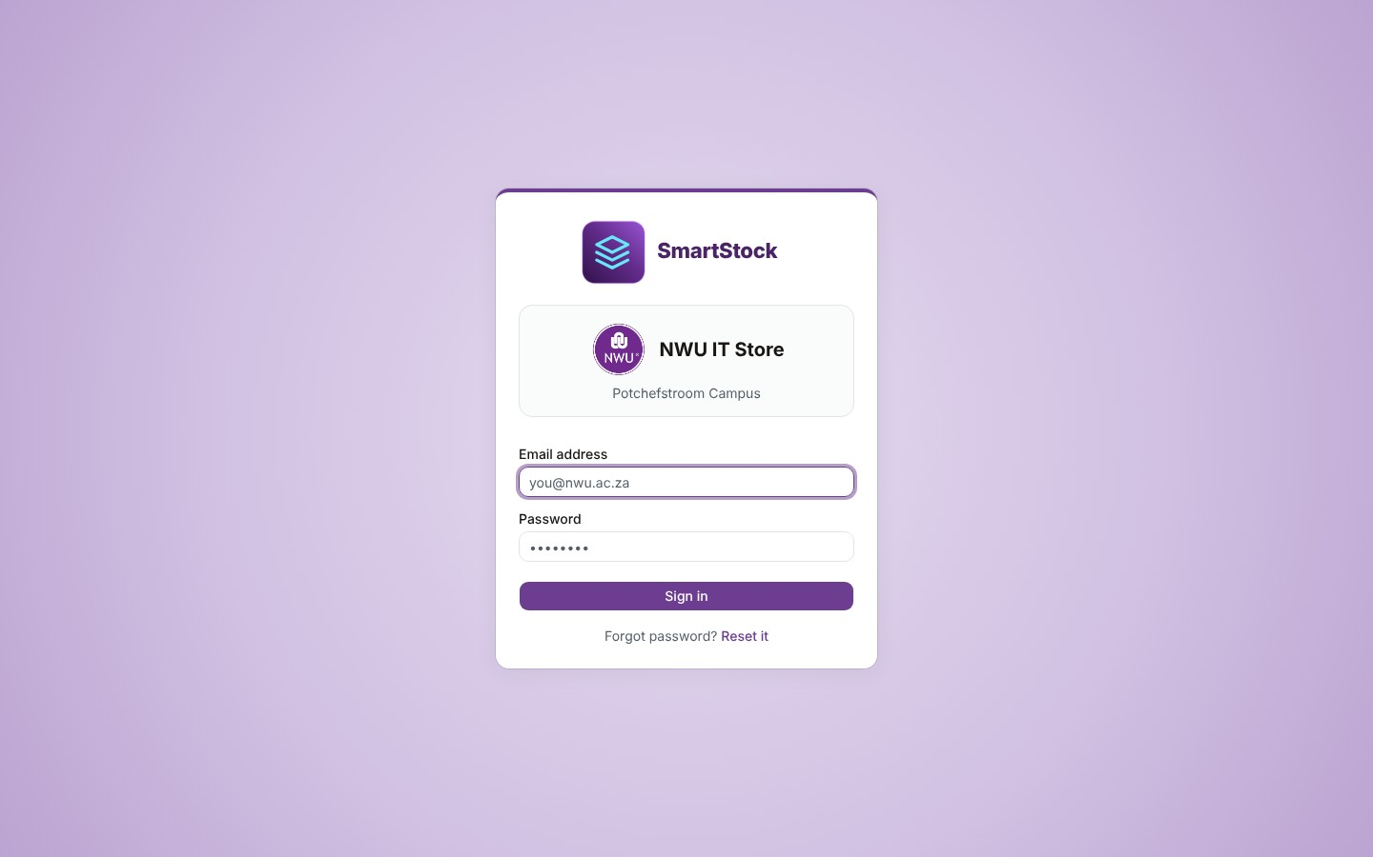
Figure 1: The sign-in page
If something is wrong, a red message appears under the password field:
Message | What it means
Incorrect email or password. | The email or the password is wrong. Check for typing mistakes and Caps Lock.
Too many attempts — please wait a moment and try again. | After several wrong passwords the sign-in service blocks the account for a short while. Wait a few minutes, or reset the password.
Your account has been deactivated. Please contact … for more information. | The administrator has deactivated this staff member (section 9.5).
This account isn't set up for BICS or portal access — contact an administrator. | The login exists, but it is not linked to an administrator or a staff record.
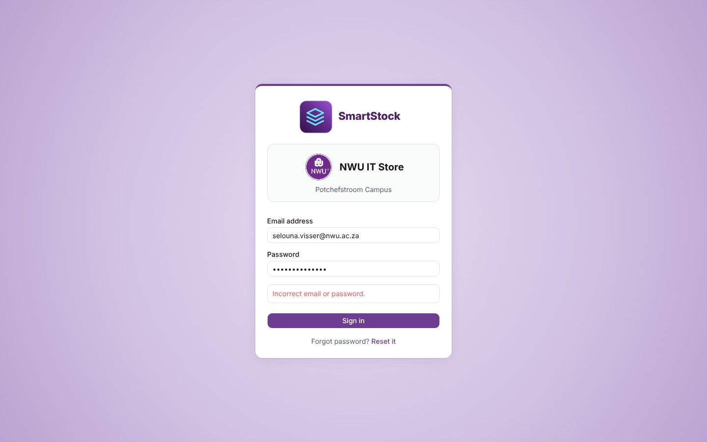
Figure 2: A wrong password

2.2 Forgot your password
- On the sign-in page, type your email address in the Email address box.
- Click Reset it (next to "Forgot password?").
- A small message appears at the top right: "Password reset email sent to …". Open the email and click the link. (The same message appears even if the address has no account, so if nothing arrives, check you typed the address you sign in with, and look in your spam folder.)
- On the page that opens, type a new password twice and click Save password, then Go to sign in.
Note: The reset link works once only. If it says "This link has expired or has already been used", request a new one from the sign-in page.
For safety you can request a reset email for the same address at most once a minute.

2.3 Password rules
Every password must have at least 12 characters, including an uppercase letter, a lowercase letter, a number and a symbol (for example !, # or @). The screen tells you exactly what is missing if a password does not meet the rule. The rule applies whenever a password is set or changed; existing passwords keep working.

2.4 Setting your password for the first time (staff)
When the administrator gives a staff member access, SmartStock emails them a message with the subject "Set your SmartStock password" and a Set your password button, which opens the Choose a new password page. (If the server's own email service is not configured, Firebase sends its standard password email instead, with its own wording and page.) The staff member chooses a password (following the rules above), clicks Save password, and can then sign in.

2.5 The administrator screen
On a computer, the administrator area has a purple sidebar on the left with every page, grouped as follows:
Group | Pages
(top) | Dashboard
Stock | Stock Out, Stock In, Returns
Catalogue | Products, Categories
Admin | Staff, Reports, Loan Requests, Audit Log, Notifications
- The arrow button at the top of the sidebar collapses it to icons only, giving the page more room. Click it again to expand.
- Your name and the "admin" badge are at the bottom. Click them to open Profile or Sign out.
- Turquoise count badges show work that needs attention. The Dashboard badge adds up the Outstanding Returns, Incoming Pickups and Low Stock rows. The Loan Requests badge counts requests waiting for you or waiting for the staff member's answer to your counter. Badges refresh by themselves every minute and whenever something changes.

2.6 Using SmartStock on a phone or tablet
On a narrow screen (or a phone turned sideways) the sidebar is replaced by a top bar. Tap the menu button (three lines) to see all pages; the small badge on it is the total of the counts. Tap the round avatar on the right for Profile and Sign out. On the Products and Reports pages the search and filter box folds into a Search & filters bar, and on the Audit Log page into a Filters bar: tap it to open the filters. Wide tables can be scrolled sideways.
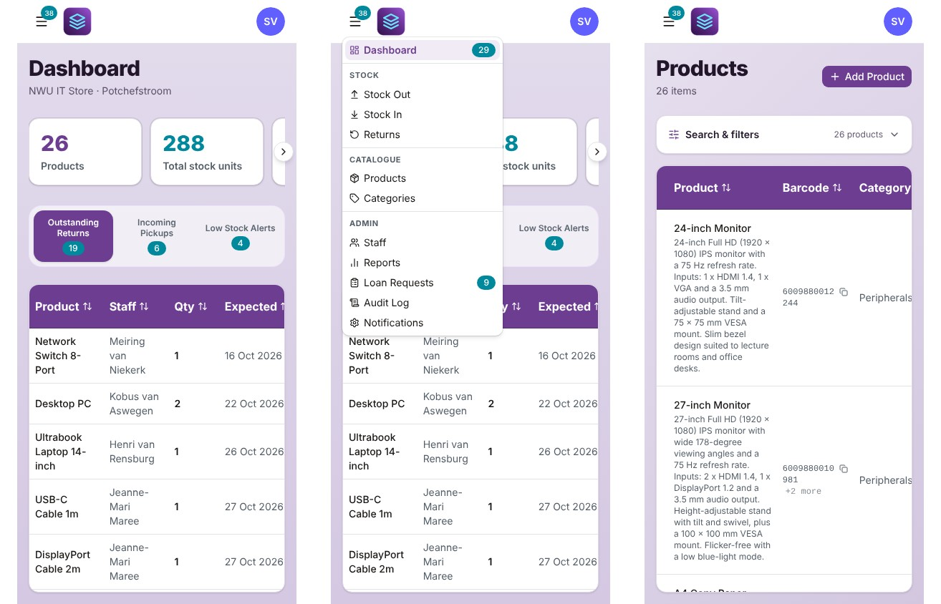
Figure 3: The admin area on a phone: Dashboard, the open menu, and Products with folded filters

2.7 Signing out
Click your name at the bottom of the sidebar (or the avatar on a phone) and choose Sign out. You are taken to the Lending Portal's Browse page. Always sign out on a shared computer.

3. Dashboard
The Dashboard is the first page after sign-in. It shows the state of the store at a glance and three lists of things that need attention.
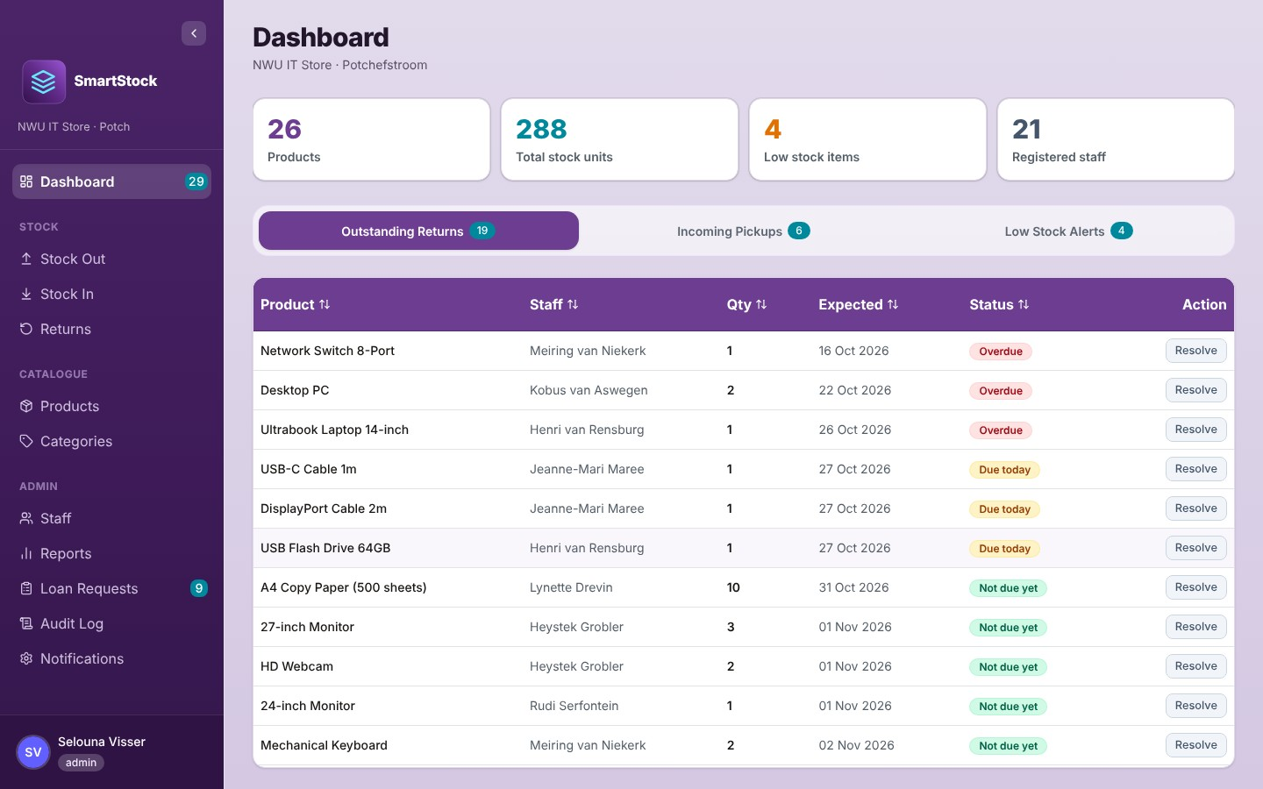
Figure 4: The Dashboard with the Outstanding Returns tab open

3.1 Summary cards
Card | Shows
Products | How many products are in the catalogue.
Total stock units | The total quantity on hand of all products together.
Low stock items | How many products are at or below their reorder threshold (including those with zero).
Registered staff | How many staff members are active.
On a phone the cards form a row you can swipe or move with the arrow buttons.

3.2 Outstanding Returns
Every item that was issued on a Stock Out and has not been returned or resolved. The soonest-due items are at the top. Click any column heading to sort by it.
Status | Meaning
Overdue (red) | The Lend To date has passed.
Due today (amber) | The item is due back today.
Not due yet (green) | The Lend To date is still ahead.
No return date (grey) | The Stock Out was made without a Lend To date. The item is listed so you know who has it, but it is never marked overdue.

Resolving an item that will not come back
If an item has been lost, damaged beyond repair or may be kept, click Resolve on its row. The dialogue explains what will happen; add an optional reason (for example "Lost by staff member") and click Resolve.
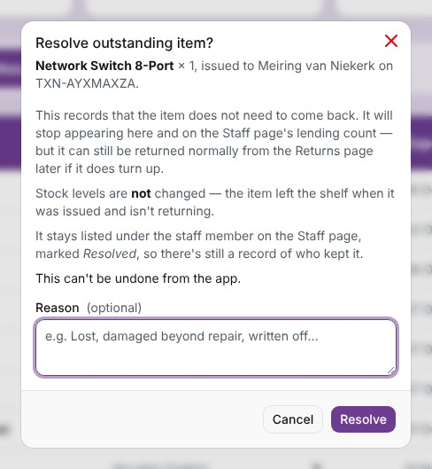
Figure 5: The Resolve dialogue
- The item stops appearing on the Dashboard and no longer counts as still owed. The staff member keeps the "Lending" status on the Staff page while the resolved item is listed under them.
- Stock levels are not changed: the item already left the shelf when it was issued.
- It stays listed under the staff member on the Staff page, marked Resolved, and the Audit Log keeps a record.
- If the item turns up later it can still be returned normally on the Returns page.
- Resolving cannot be undone from the app.

3.3 Incoming Pickups
Loan requests you have approved that the staff member still has to collect. Click a row to see the items.
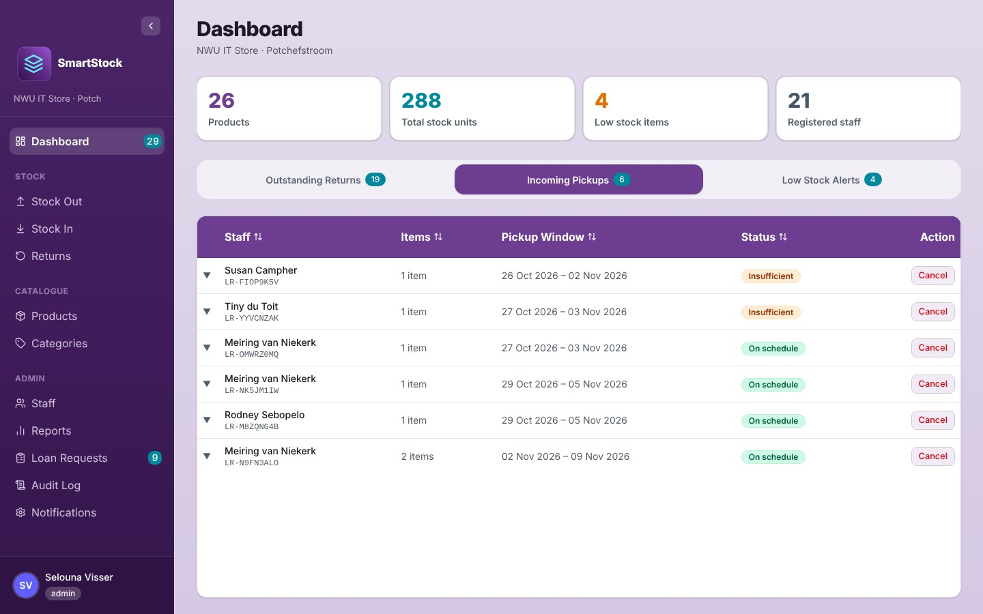
Figure 6: The Incoming Pickups tab
Status | Meaning
On schedule (green) | Everything is in order.
Insufficient (orange) | At least one item does not have enough free units right now. Expand the row: it shows how many are short and, where possible, the overdue loan that is the likely cause (for example "1 unit with Kobus van Aswegen, expected 14 Oct 2026"). Chase that return or reduce the pickup.
If nobody collects an approved pickup by the last day of its pickup window, SmartStock closes the request with the status Not picked up and it leaves this list; the reserved units become available again. A pickup with no return date is never closed this way.
To cancel an approved pickup, click Cancel on the row, optionally type a reason, and click Cancel pickup. The reserved units become available again and, if the "Approved pickup cancelled" email is switched on, the staff member is told by email (with your reason).

3.4 Low Stock Alerts
Products whose quantity is at or below the reorder threshold, lowest first. Out of stock (red) means zero on hand; Low stock (amber) means at or below the threshold. To fix it, receive more stock on the Stock In page or adjust the threshold on the Products page.
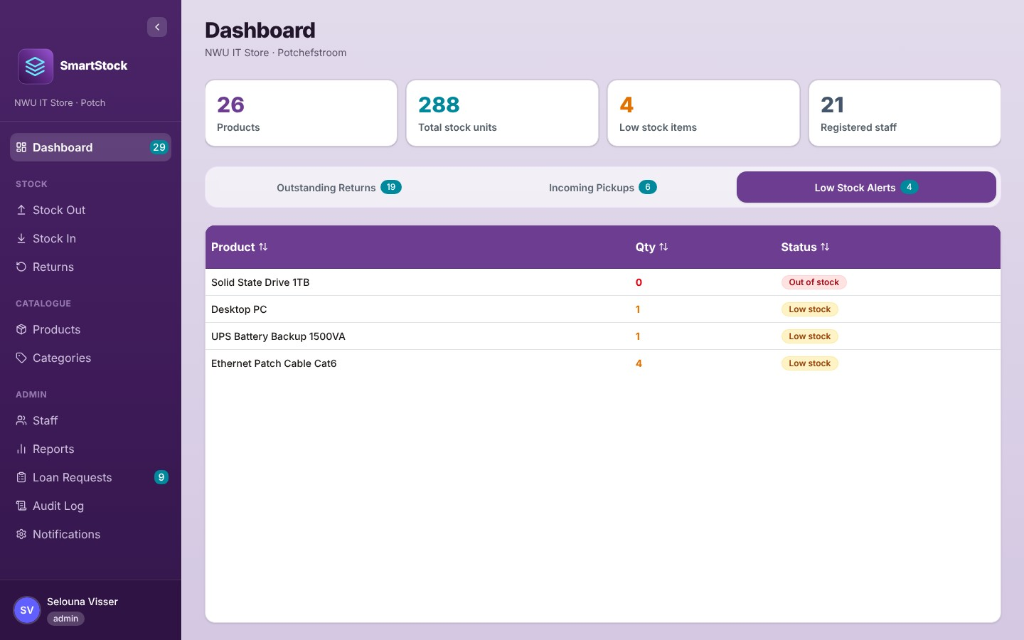
Figure 7: The Low Stock Alerts tab

4. Stock Out: issuing equipment
Use Stock Out whenever equipment leaves the store on loan. The page works in three steps shown at the top: 1 Identify Staff → 2 Scan Items → 3 Confirm. You can click an earlier, completed step to go back (going back to step 1 starts over).

4.1 Step 1: identify the staff member
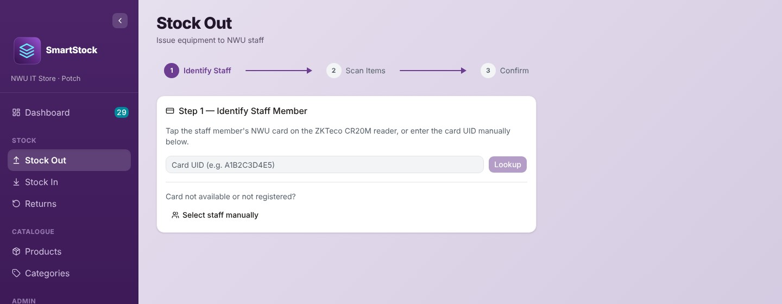
Figure 8: Step 1: identify the staff member
With an NWU card (preferred): ask the staff member to tap their card on the ZKTeco CR20M reader. The reader types the card UID and SmartStock finds the person automatically. You can also type the UID into the Card UID box and click Lookup.
Without a card: click Select staff manually, type part of the name or email in the search box, and click the person.
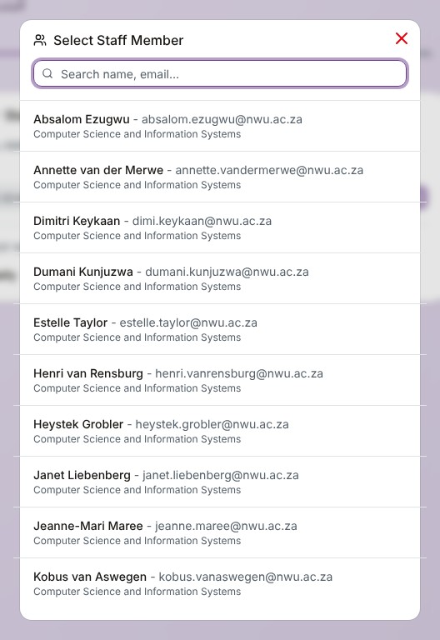
Figure 9: Selecting a staff member manually
Note: A manual selection is flagged: you will see a "Manual selection" badge, and the transaction is recorded in the Audit Log as "Manual entry — no card scan". Only active staff members can be selected.

4.2 Step 2: scan the items
Scan each item's barcode with the barcode scanner (or type it in the box and press Enter). Each scan adds one unit. For walk-in items, use the − and + buttons to change a quantity. The red × removes a line. You cannot add more units than the store has on hand.
If the staff member has an approved loan request, it is listed under Accepted Loan Requests. Click it to load the approved items and dates. Each unit then shows "Awaiting scan" until you scan it, so the right physical items are recorded. The quantities of a request are fixed at what was approved; removing a scanned request line puts its units back to "Awaiting scan". You can add walk-in items on top of the request.
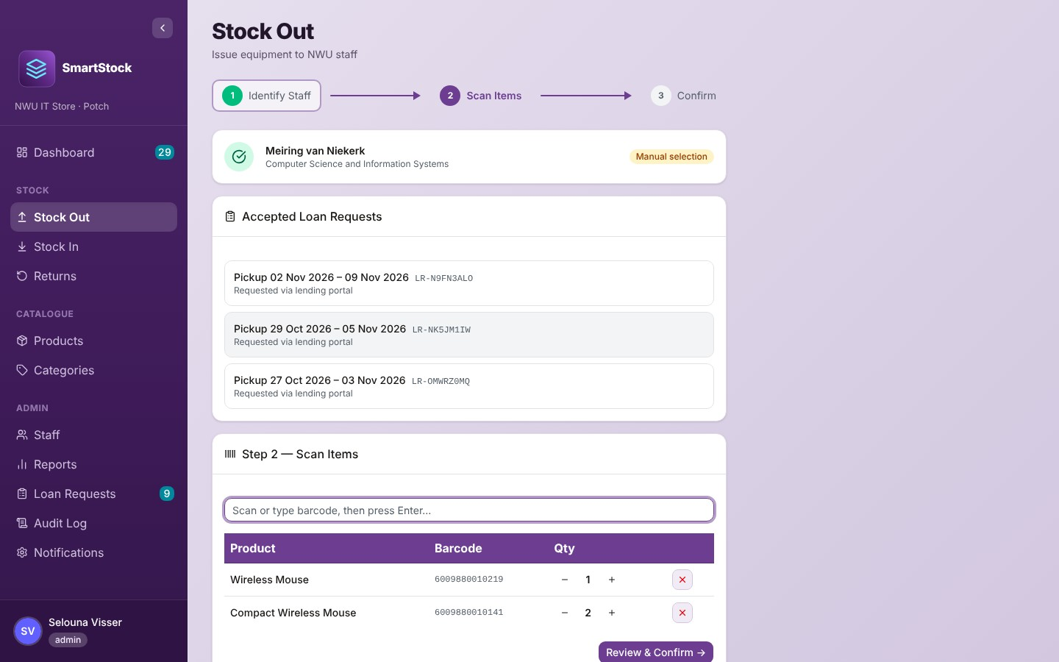
Figure 10: Step 2: the scanned items, with the staff member's approved requests listed above
When everything is scanned, click Review & Confirm →.

4.3 Step 3: confirm
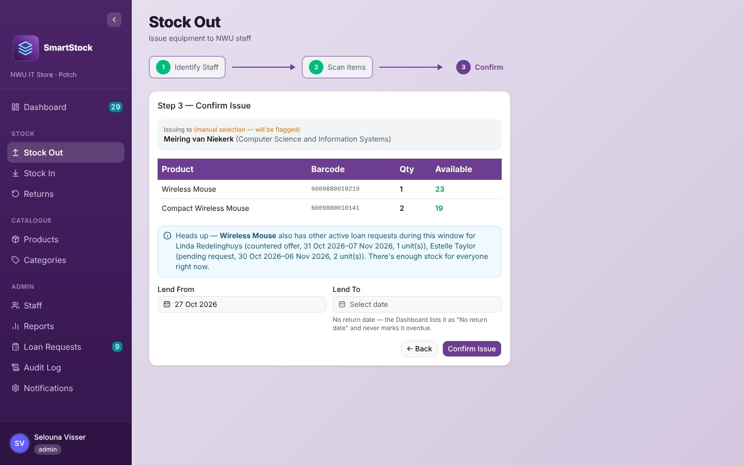
Figure 11: Step 3: confirm the issue
- Check the staff member and the items. The Available column shows the stock on hand.
- Set Lend From (today or later) and Lend To (the date the item must come back). Leave Lend To empty only if the item does not need to come back (for example consumables). The Dashboard still lists it under Outstanding Returns as "No return date", but never marks it overdue.
- A blue "Heads up" note means someone else also has a loan request for this item in the same period, but there is enough stock for everyone. You may continue.
- A red "can't be issued" message means the units are reserved for another staff member's request. Sort that out first (cancel the other pickup on the Dashboard, or decide the pending request on Loan Requests). Confirm Issue stays disabled until then.
Click Confirm Issue. A success screen shows the transaction reference; click New Transaction for the next person.

4.4 What happens after a Stock Out
- The stock on hand goes down. SmartStock never lets stock go below zero.
- If you issued an approved loan request, it becomes Fulfilled.
- The staff member receives a Stock Out confirmation email listing what they took and when it is due back (if that email is switched on and they have an email address).
- If the issue took a product from above its reorder threshold to the threshold or below, the administrator receives a Low stock email at the Admin notification address (if the "Low stock / out of stock alert" switch is on). It is not repeated while the product stays low.
- The item now appears on the Dashboard under Outstanding Returns (as "No return date" if Lend To was left empty) and on the Staff page.
Note: Emails are sent after the save. If an email cannot be sent you will see "Stock Out saved, but the notification emails couldn't be sent." The Stock Out itself is still saved.

5. Stock In: receiving stock
Use Stock In when new stock arrives, for example a delivery from a supplier.
- Scan each item's barcode (or type it and press Enter). Click into the scan box first if it is not highlighted.
- Each scan adds one unit. Use − / + to change the Receiving quantity; After shows what the stock will be.
- Optionally type Notes, such as the supplier, delivery note or order number.
- Click Confirm Receipt. The success screen shows the reference. Click New Stock-In for the next delivery.
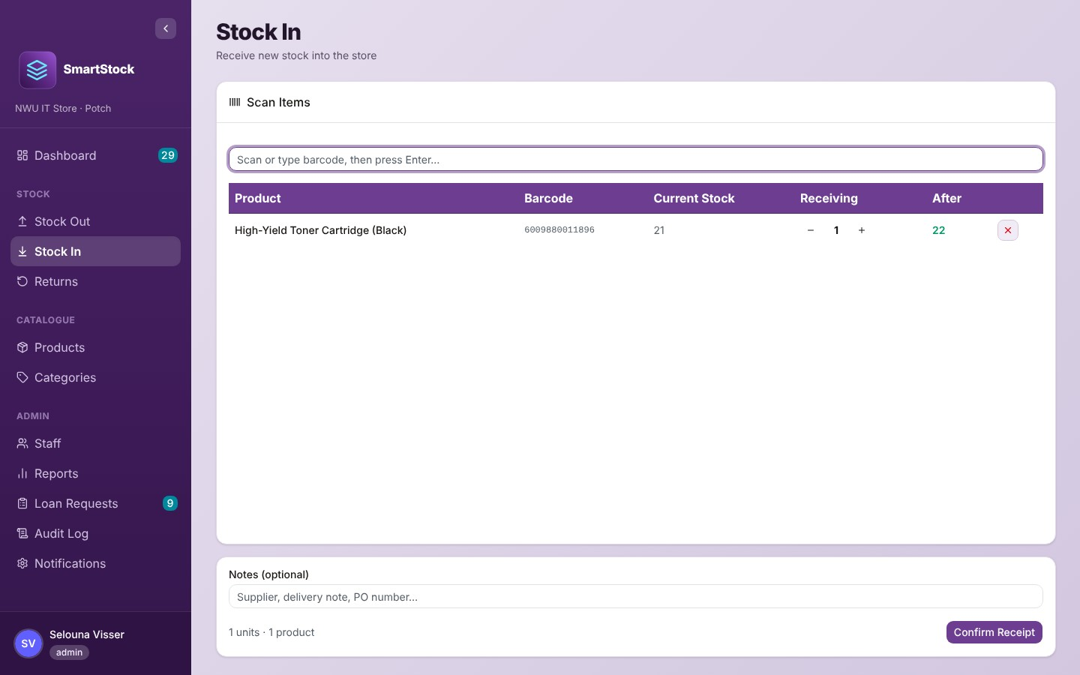
Figure 12: Receiving a delivery on Stock In
Tip: Only barcodes already registered on a product can be scanned here. For a brand-new product, first add it on the Products page (chapter 7) with its barcode, then receive it here.

6. Returns: taking equipment back

6.1 Identify the staff member
As on Stock Out: tap the staff member's card, type the card UID and click Lookup, or click Select staff manually. A person chosen from the list gets a Manual badge, and the return is marked "Manual entry — no card scan" in the Audit Log. Only active staff members can be chosen.

6.2 Scan the returned items
The table Items Currently Issued lists everything the person still has, one row per barcode, oldest loan first. Scan each returned item; every scan returns one unit and the Returns Scanned column counts up. The barcode must be the same one that was scanned when the item was issued.
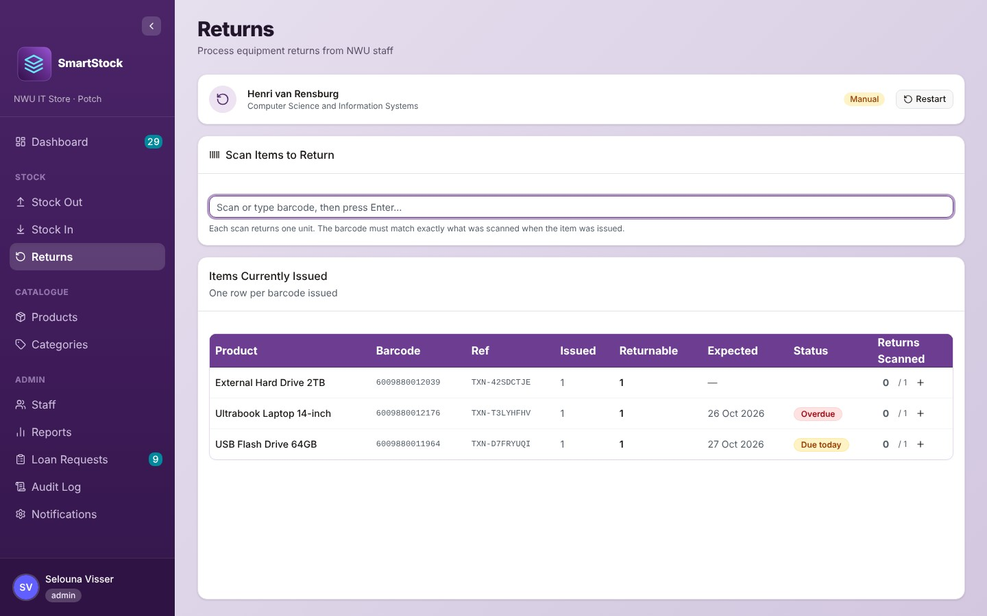
Figure 13: Items currently issued to a staff member
Status | Meaning
Partial (amber) | Some units under this barcode were already returned; the rest are still owed.
Overdue / Due today / Not due yet | Same meaning as on the Dashboard.
(no badge) | The loan had no return date.
When everything is scanned, click Confirm Return. The success screen lists one reference per return (one per original Stock Out). Stock on hand goes up by the units returned. If you selected the wrong person, click Restart.

6.3 When an item has lost its barcode label
If the label has come off and the item cannot be scanned:
- Stick one of the product's other registered barcodes on the item (or add a new barcode to the product first on the Products page, under Edit).
- On the Returns page, click the + at the end of the item's row.
- In the Barcode lost dialogue, scan or type the barcode that is now on the item and click Use this barcode.
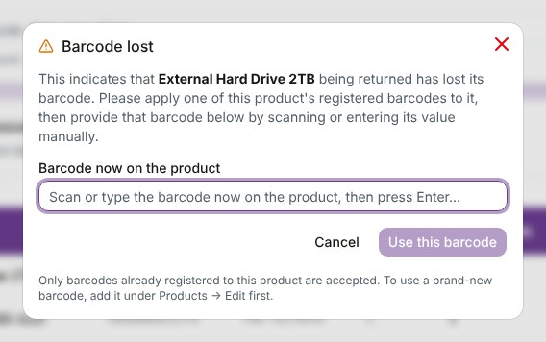
Figure 14: The Barcode lost dialogue
The return counts against the original loan, and the record notes which label it came back with.
Note: Items that were resolved (written off) still appear here and can be returned normally if they turn up.
Very old Stock Outs recorded without a barcode cannot be returned by scanning; they are listed in an amber box. Resolve them from the Dashboard instead.

7. Products
The Products page is the store catalogue. Here you add products, register their barcodes and photos, set reorder thresholds, and decide what may be borrowed on the Lending Portal.
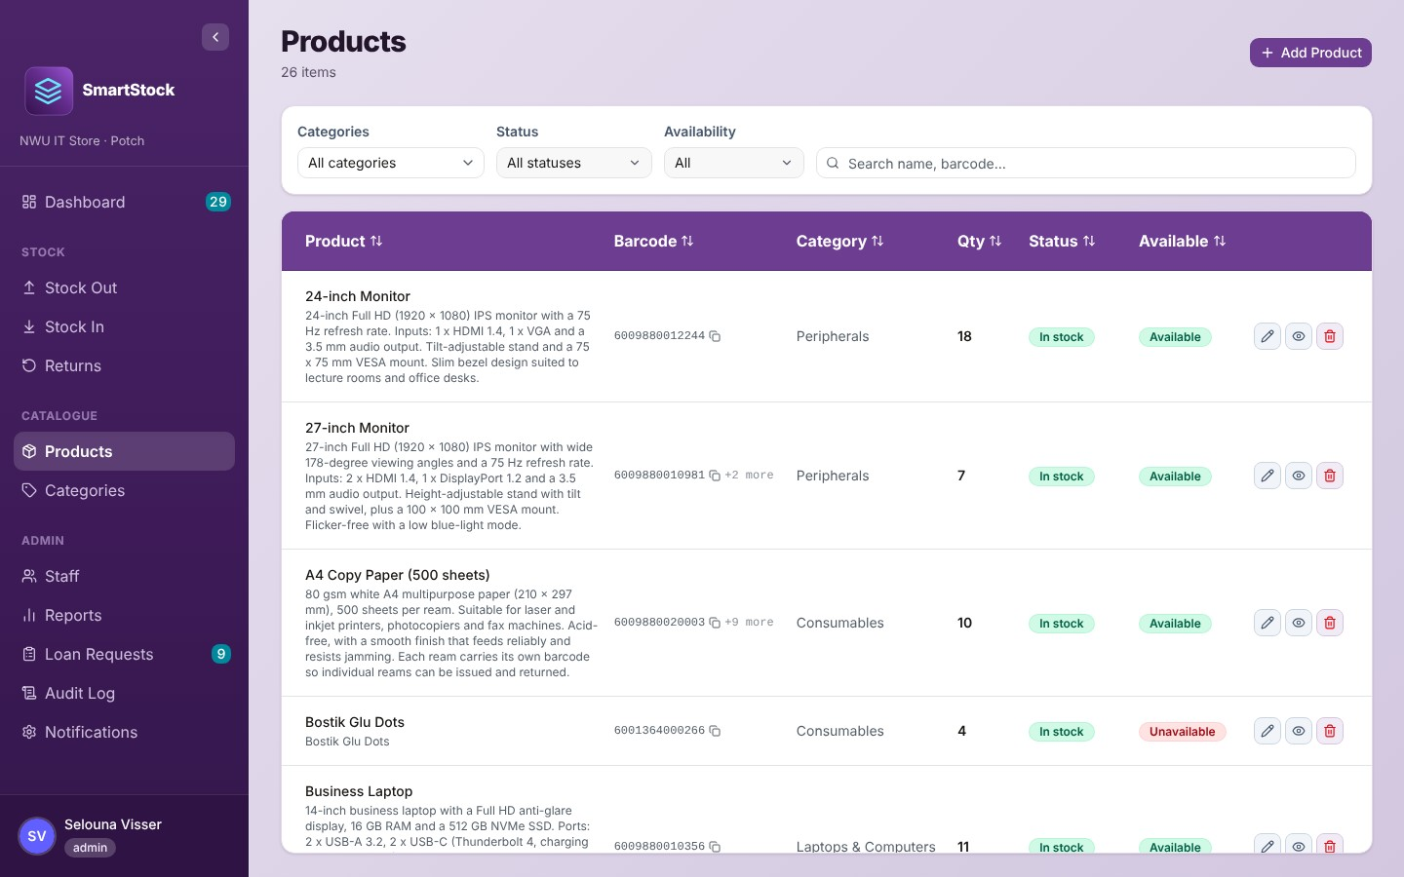
Figure 15: The Products page

7.1 Finding products
- Categories: show one category only.
- Status: Out of stock, Low stock, In stock (tick one or more).
- Availability: Available or Unavailable on the portal.
- Search: type part of a product name or any of its barcodes.
- Click a column heading to sort. The Barcode column shows the product's primary (first) barcode, with "+N more" if it has others. Click the copy icon next to it to copy it (for example to paste into label-printing software).
Each row has three buttons: the pencil edits, the eye previews, and the red bin deletes.
Badge | Meaning
In stock / Low stock / Out of stock | Quantity above the threshold / at or below the threshold / zero.
Available / Unavailable | Available means the product's Availability is switched on and there is at least one on hand. Only available products can be added to a cart on the Lending Portal.

7.2 Adding a product
Click Add Product and fill in the dialogue.
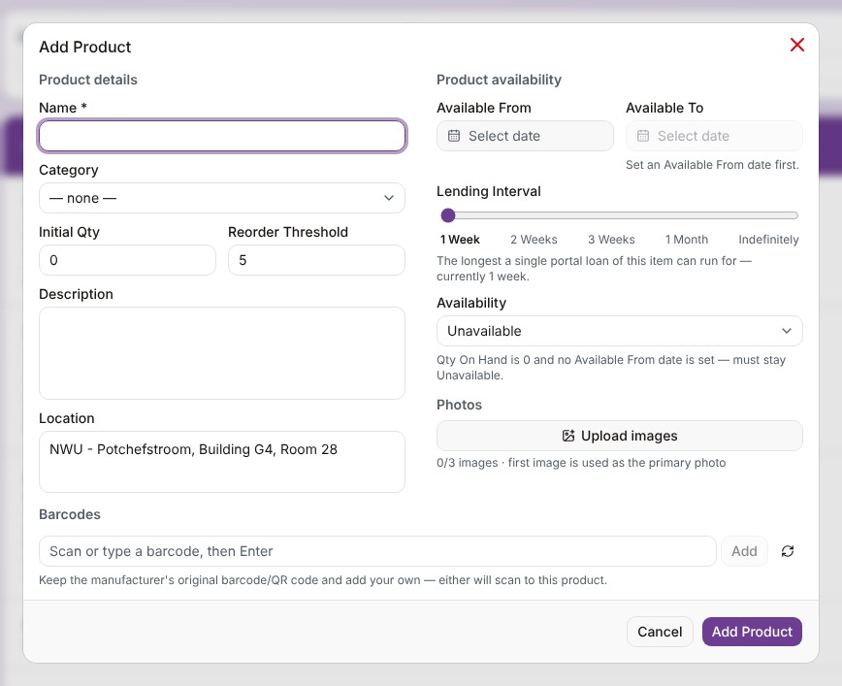
Figure 16: The Add Product dialogue
Field | How to fill it
Name * | Required. The name staff will see on the portal.
Category | Optional. Choose a category (create categories first on the Categories page).
Initial Qty | How many are on the shelf now (0 or more).
Reorder Threshold | When the quantity drops to this number the product becomes "Low stock" (default 5).
Description, Location | Shown to staff in the product preview. Location defaults to "NWU - Potchefstroom, Building G4, Room 28".
Available From / Available To | The period in which the product may be borrowed on the portal. A product only appears on the portal if Available From is set. Available To must be after Available From; leave it empty if the product is always available after that date.
Lending Interval | The longest a single portal loan may last: 1 Week, 2 Weeks, 3 Weeks, 1 Month or Indefinitely (no return date needed).
Availability | Available or Unavailable on the portal. New products start as Unavailable. It can only be set to Available when the quantity is above 0 and Available From is set; setting the quantity to 0 or clearing Available From switches it back to Unavailable.
Photos | Up to 3 images (JPEG, PNG, WebP or GIF). Large photos, such as those from a phone, are reduced automatically before upload. The first one is the main photo; drag to change the order.
Barcodes | At least one is required. Scan the manufacturer's barcode or type one and press Enter or Add. Click the refresh icon to generate a new NWU barcode (BC-…), then copy the value into the label-printing software. You can register several barcodes; the first is the primary one.
Click Add Product to save.

7.3 Editing a product
Click the pencil. The same dialogue opens with the current details. Next to each barcode a blue badge shows how many units carry it and an amber badge shows how many are out on loan.
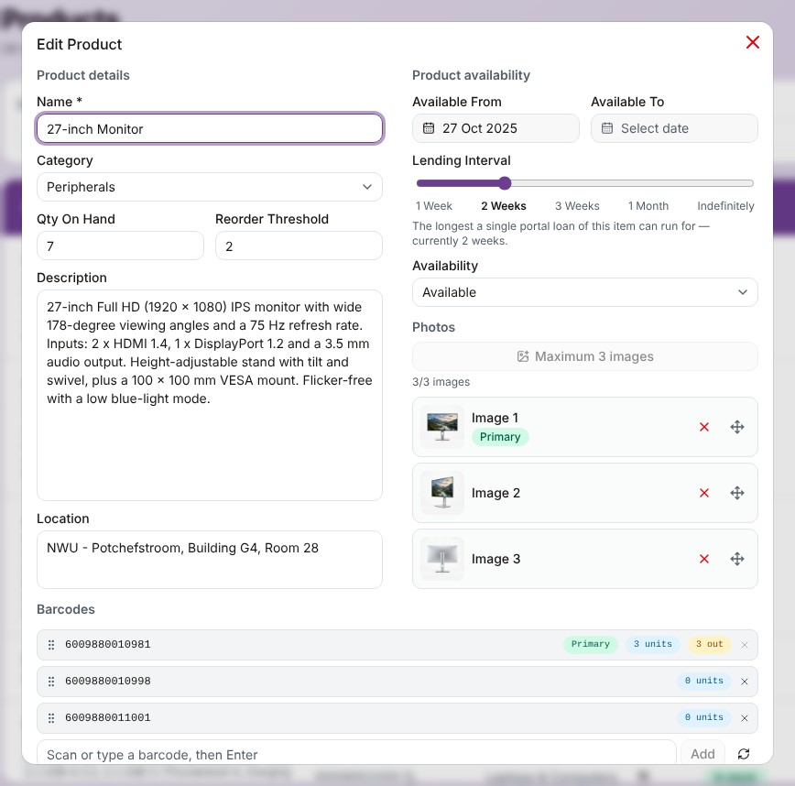
Figure 17: Editing a product: lending settings, photos and barcodes
- If you change Qty On Hand, you must give a Reason (for example "Stock count correction"). The reason is kept in the Audit Log. This is a correction, not a Stock In or Stock Out.
- You cannot save a quantity that would leave an approved pickup, a countered offer or a pending loan request short of stock. The message names the staff member and says whether to cancel the pickup on the Dashboard or deal with the request on Loan Requests.
- A barcode cannot be removed while units issued under it are still out. For a barcode that was already saved you are asked to confirm, and it is removed when you click Save Changes; a barcode you only just added comes off straight away.
- If the edit makes the product newly low (it was above its reorder threshold and is now at or below it, by lowering the quantity or raising the threshold), the administrator receives a Low stock email (if that switch is on).
- Save Changes only becomes active once you have changed something.

7.4 Previewing a product
Click the eye icon to see the product much as staff see it on the portal: photos, category, availability, location, the period it can be borrowed in, the lending interval and the description. The preview has no Add to Cart button, and for a product with no stock the badge reads "Unavailable — return date not set" (the expected return date is only shown on the portal).
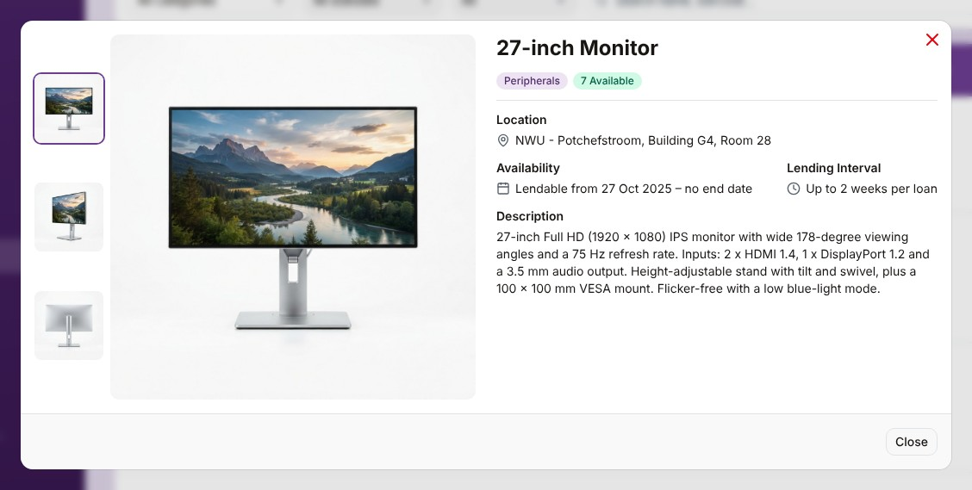
Figure 18: Product preview

7.5 Deleting a product
Click the red bin. SmartStock first checks whether units are still checked out or reserved; if so, the dialogue says "Still in use" and Delete stays disabled. Otherwise the dialogue allows the delete, but the system still refuses to delete a product that has any stock history (Stock In, Stock Out or loan request records), because that history must be kept. In that case clicking Delete shows "Could not delete this product. This product has stock history (Stock In/Out records) and can't be deleted." A product that is deleted also loses its photos.
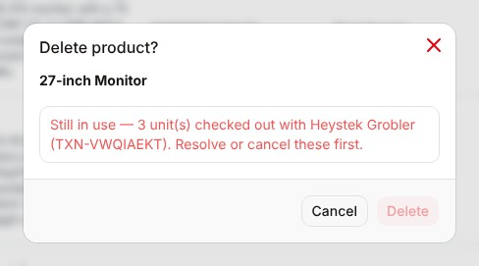
Figure 19: A product that cannot be deleted because units are still out
Tip: To retire a product that has history, set its Availability to Unavailable instead of deleting it.

8. Categories
Categories group products (for example Cables & Adapters, Peripherals, Storage). They are used as filters on Products, Reports and the Lending Portal.
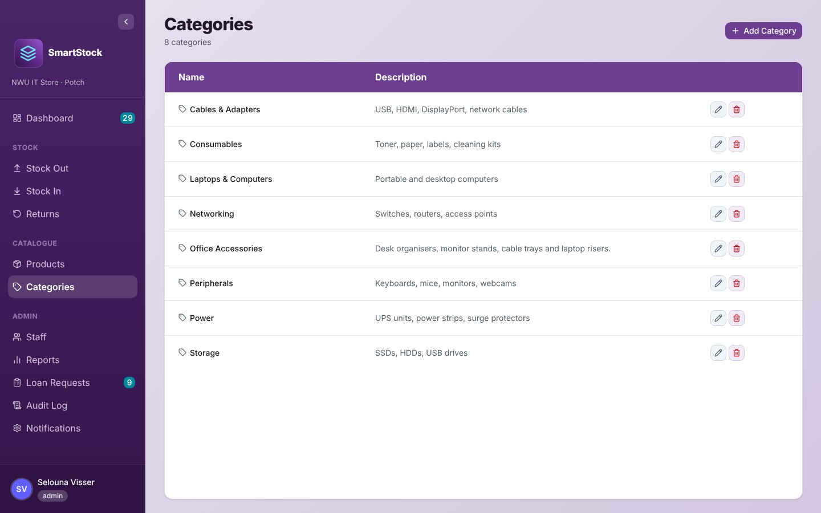
Figure 20: The Categories page
- Add: click Add Category, enter a Name and Description (both required) and click Add Category. Two categories cannot have the same name.
- Edit: click the pencil, change the details and click Save Changes. Renaming a category does not change the category name already stored on its products: each product shows the new name after it is next saved.
- Delete: click the red bin. A category that is still used by products cannot be deleted; move those products to another category first.
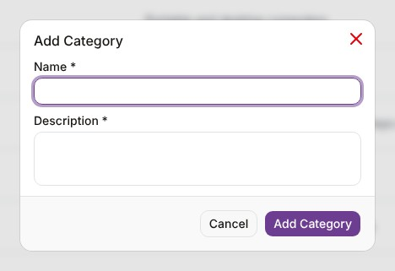
Figure 21: Adding a category

9. Staff
The Staff page is the list of people who may borrow equipment. Here you link NWU cards, give staff access to the Lending Portal, deactivate people who leave, and see what each person currently holds.
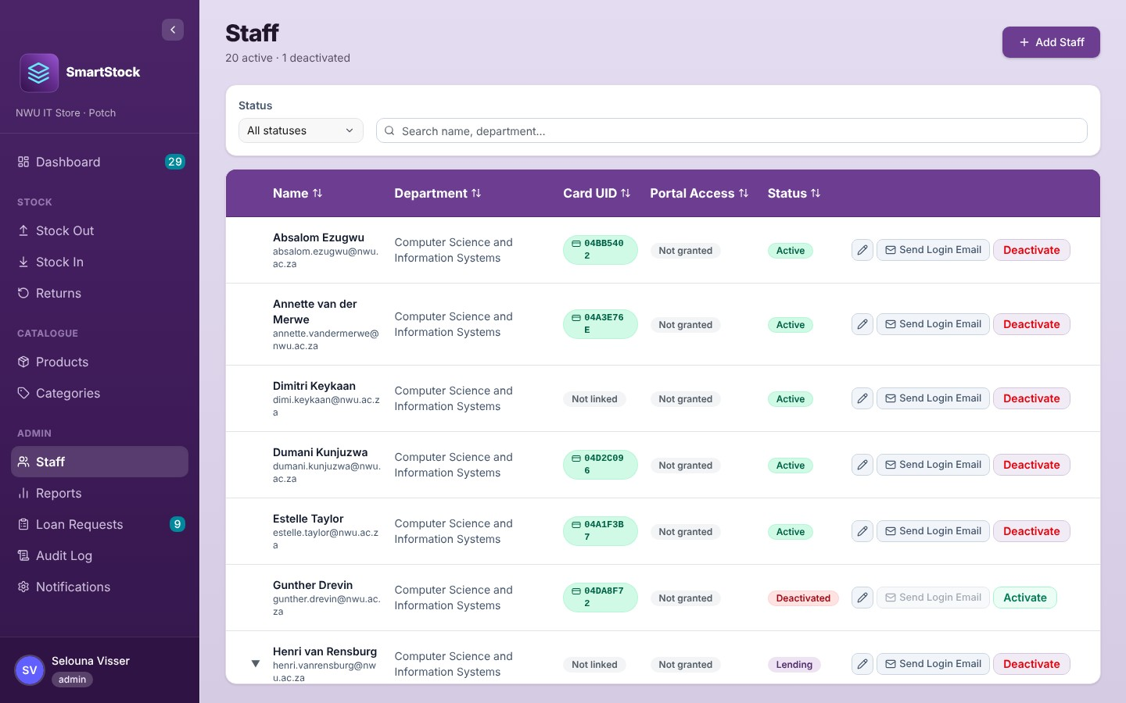
Figure 22: The Staff page

9.1 Finding staff
Filter by Status (Active, Lending, Deactivated; tick one or more) or type a name or department in the search box. The heading shows how many of the people matching the search are active and how many are deactivated.
Column / badge | Meaning
Card UID | Green pill with the card number, or "Not linked".
Portal Access | "Granted" when the person has a portal login; otherwise "Not granted".
Active (green) | Can borrow; holds no items.
Lending (purple) | Holds at least one item, including items marked Resolved (they stay with the person).
Deactivated (red) | Switched off. Cannot be selected on Stock Out or Returns and cannot use the portal. Their history is kept.

9.2 Adding or editing a staff member
Click Add Staff (or the pencil on a row). Fill in Name, Surname, Email and Department (all required). For Card UID, click in the box and tap the person's card on the reader, or leave it blank and link it later. Click Add Staff / Save Changes.
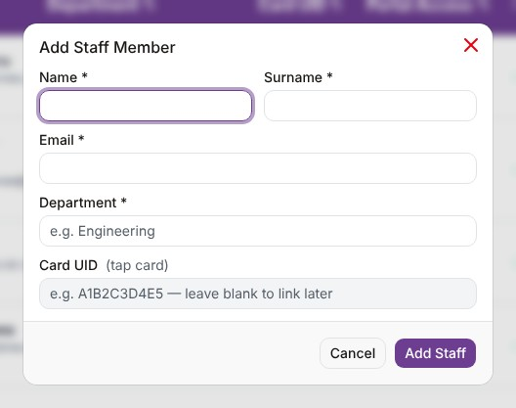
Figure 23: Adding a staff member
Note: Each email address and each card can belong to one staff member only. If the person already has portal access and you change their email, their login email changes too.

9.3 What a staff member holds
Rows with an arrow on the left belong to people who hold items. Click the arrow to see each item, its due date and status. Resolve works exactly as on the Dashboard (section 3.2); resolved items stay listed with a violet Resolved badge.
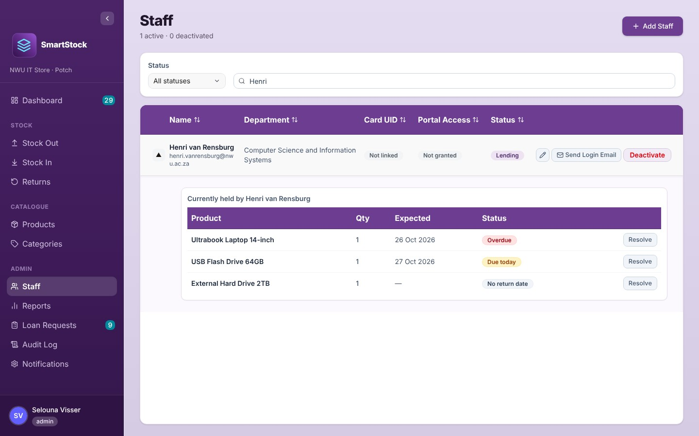
Figure 24: Items currently held by a staff member

9.4 Giving portal access (Send Login Email)
Click Send Login Email on the staff member's row. SmartStock creates their portal login (if they do not have one yet), marks Portal Access as Granted and emails them a link to set their password (subject "Set your SmartStock password" when the server's email service is configured; otherwise Firebase's standard password email). A message confirms "Login email sent to …". If they lose the email or the link expires, click Resend Login Email. The button is disabled for deactivated staff and for staff without an email address.

9.5 Deactivating and activating
Click Deactivate on the row, check the name in the confirmation and click Deactivate. Deactivated staff cannot sign in to the portal and cannot be chosen on Stock Out or Returns; their records and history are kept. Click Activate (and confirm) to switch them on again.
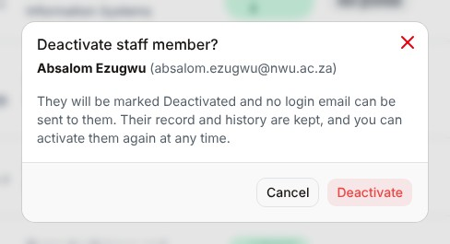
Figure 25: Confirming a deactivation
Important: SmartStock does not stop you from deactivating someone who still holds items. Their items stay on the Outstanding Returns list. Deactivated staff cannot be chosen on Returns, so to take the items back, click Activate first; or use Resolve if the items will not come back.

10. Loan Requests
Staff members request equipment on the Lending Portal. Their requests arrive here for you to approve, change (counter) or decline. The page has two tabs:
- Needs Review: new requests waiting for your decision.
- Sent Counters: requests where you sent a counter and are waiting for the staff member to accept or decline.
Approved requests leave this page; you will find them on the Dashboard under Incoming Pickups and on Stock Out when the person comes to collect. The Expires column shows the last day an unanswered request stays open: 30 days after its last change, or its requested start date if that is sooner. If nobody has acted by the end of that day, it closes as Expired.

10.1 Reviewing a request
Click a request to open it. You see the requested dates, the staff member's message and each item with the Requested and Offering quantities.
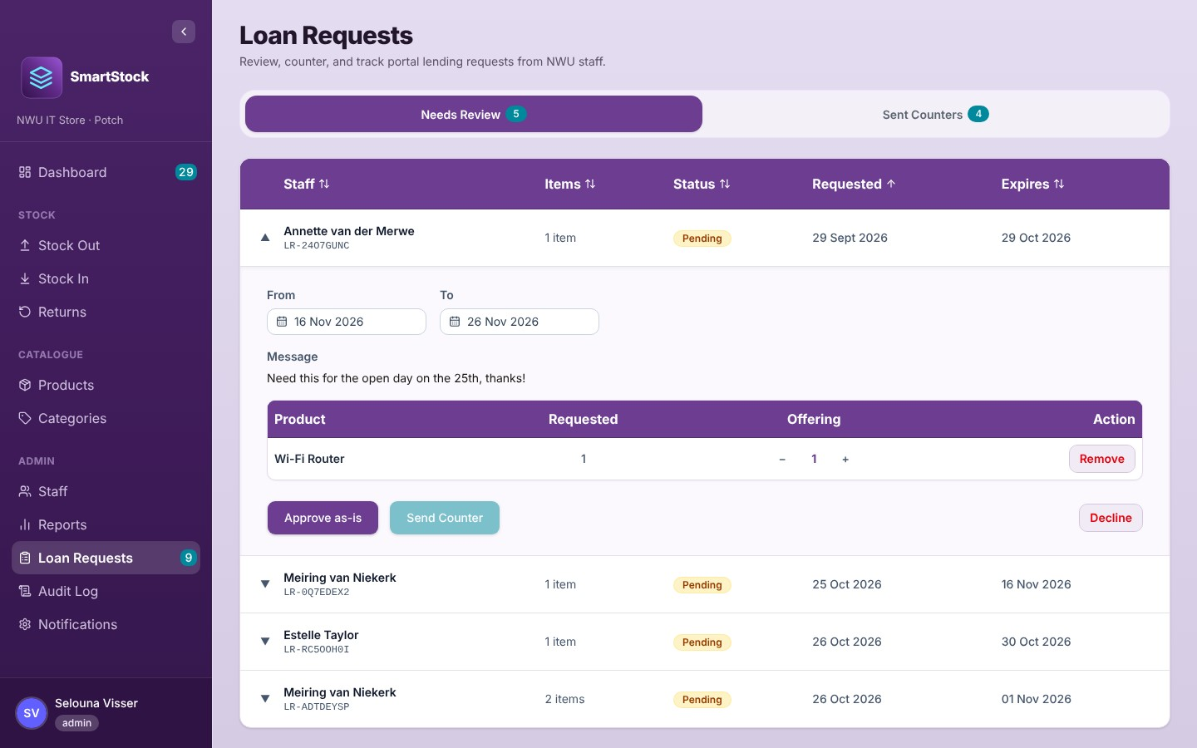
Figure 26: An open request on the Needs Review tab
To… | Do this
Approve it exactly as asked | Click Approve as-is. The pickup appears on the Dashboard under Incoming Pickups and the staff member is emailed (if that email is switched on). Approve as-is is disabled once you have changed a date or quantity.
Offer something different | Change the From / To dates and/or use − / + (or Remove) to change the quantities. You cannot offer more than was requested or more than is available. Then click Send Counter (it needs at least one unit offered), add an optional message and confirm. The staff member must accept or decline.
Turn it down | Click Decline, add an optional message for the staff member (for example "Out of stock for the dates requested") and confirm. They see it with the declined request.
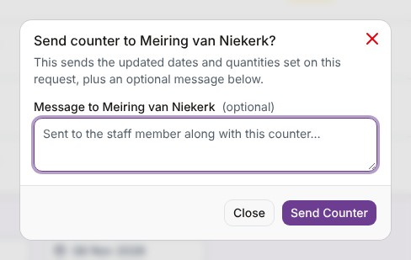
Figure 27: Sending a counter-offer
Note: SmartStock checks live availability when you approve or counter. If stock was taken in the meantime you will see "Availability changed since this request was submitted — not enough stock remains for one of the lines."
Pending, countered and approved requests all count against the units available for their dates, so the same units cannot be promised twice. Stock only leaves the shelf when you issue it on Stock Out.

10.2 Counters waiting for an answer
On Sent Counters, open a request to see the original request next to your offer and your message. You can wait for the staff member, or click Decline to withdraw the offer.
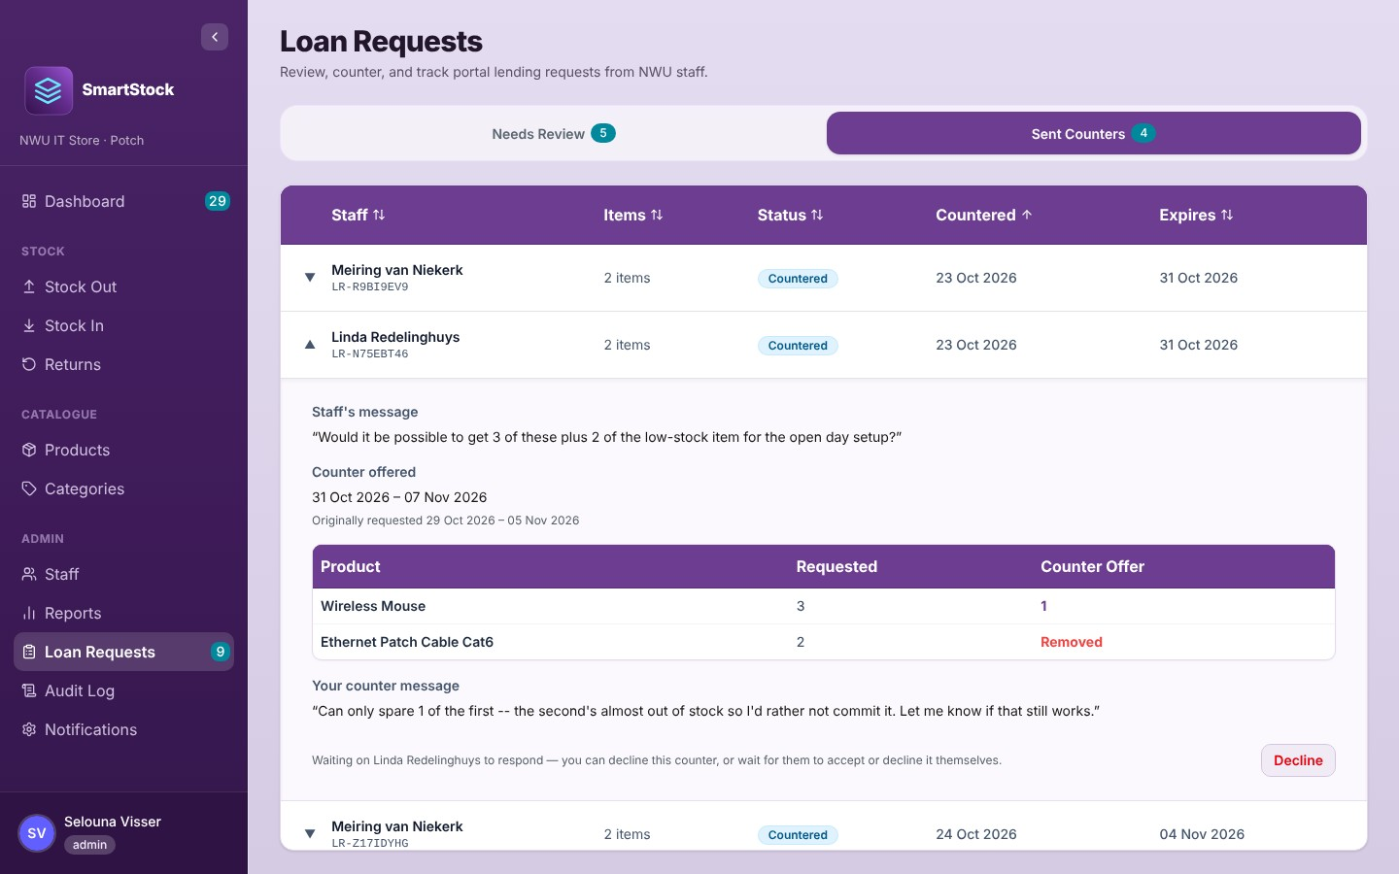
Figure 28: A counter-offer waiting for the staff member

10.3 The life of a loan request
Status | Meaning
Pending | Submitted by the staff member; waiting for you. The units already count against availability for those dates.
Countered | You sent a counter; waiting for the staff member.
Accepted | Approved (by you, or the staff member accepted your counter). The units stay reserved; waiting for pickup.
Fulfilled | The items were issued on Stock Out.
Declined | You declined it, or the staff member declined your counter.
Withdrawn | The staff member withdrew it, or you cancelled the pickup on the Dashboard.
Expired | A pending or countered request nobody answered in time.
Not picked up | Approved, but the whole pickup window passed without collection (never for a request with no return date).

11. Reports
Reports are read-only views of the store with filters, sorting and export. There are four tabs. Every tab has Export CSV (opens in Excel) and Export PDF (A4 landscape). Exports contain all rows that match your filters and search, not only the page on screen. At the bottom, choose 10, 20 or All rows per page.

11.1 Current Stock Levels
Every product with its category, quantity on hand, threshold and status. Filter by category and status, or search by name or category.
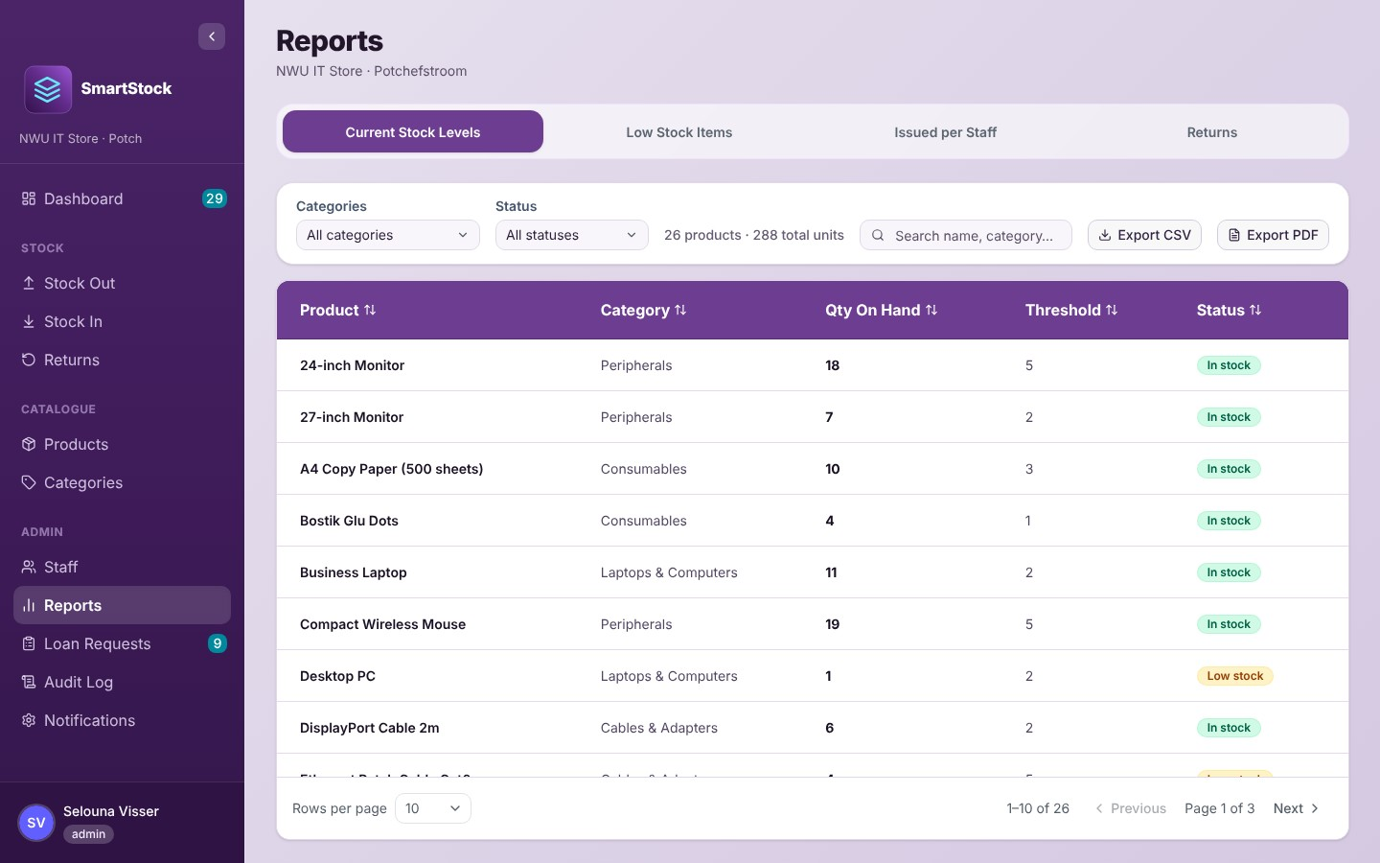
Figure 29: Current Stock Levels

11.2 Low Stock Items
Only the products at or below their reorder threshold, lowest first, with the Shortage (how many below the threshold). Use it as a shopping list.
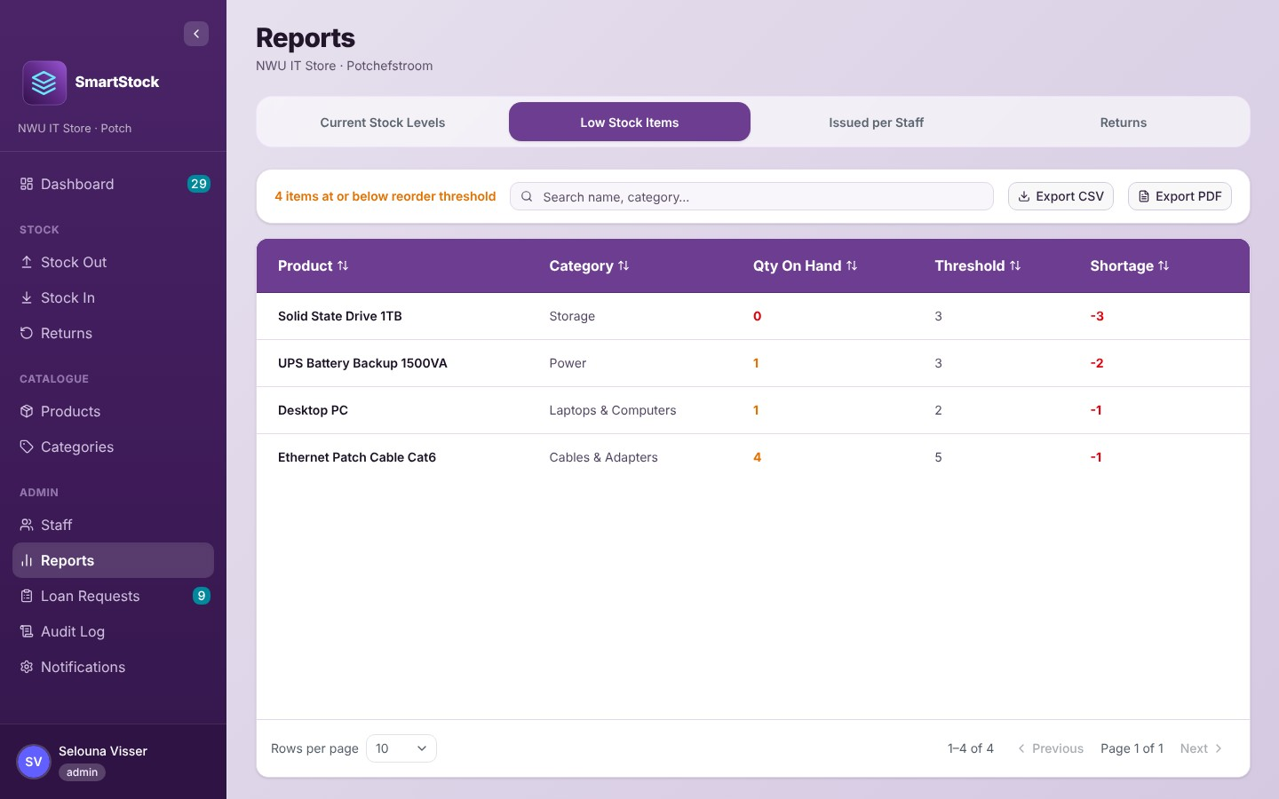
Figure 30: Low Stock Items

11.3 Issued per Staff
One row per active staff member with their number of Stock Outs and items issued. When you set a date, only staff with at least one matching Stock Out are listed. Click a row to see each Stock Out (reference, date, products, barcodes and due date).
- Issued from: only count Stock Outs recorded on or after this date.
- Expected back by: only count Stock Outs due back on or before this date. If some Stock Outs have no return date, a switch Include N with no expected date appears (on by default); switch it off to leave them out.
- Clear dates removes both dates.
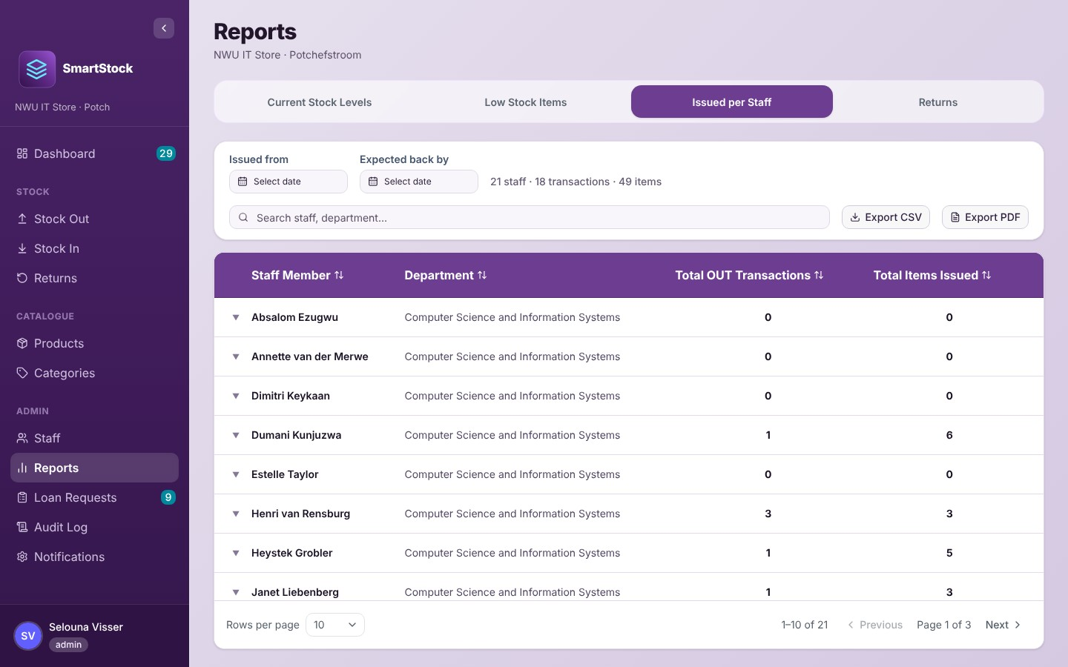
Figure 31: Issued per Staff

11.4 Returns
Every return, newest first, with what came back, the Stock Out it settled, the due date and the date returned.
Status | Meaning
Early (green) | Returned before the due date.
On time (blue) | Returned on the due date.
Late (red) | Returned after the due date.
Partial (amber) | The original Stock Out still has items owed. Click the row to see what is still outstanding.
Expected from / Expected to filter on the due date of the original loan (not the date it was returned).
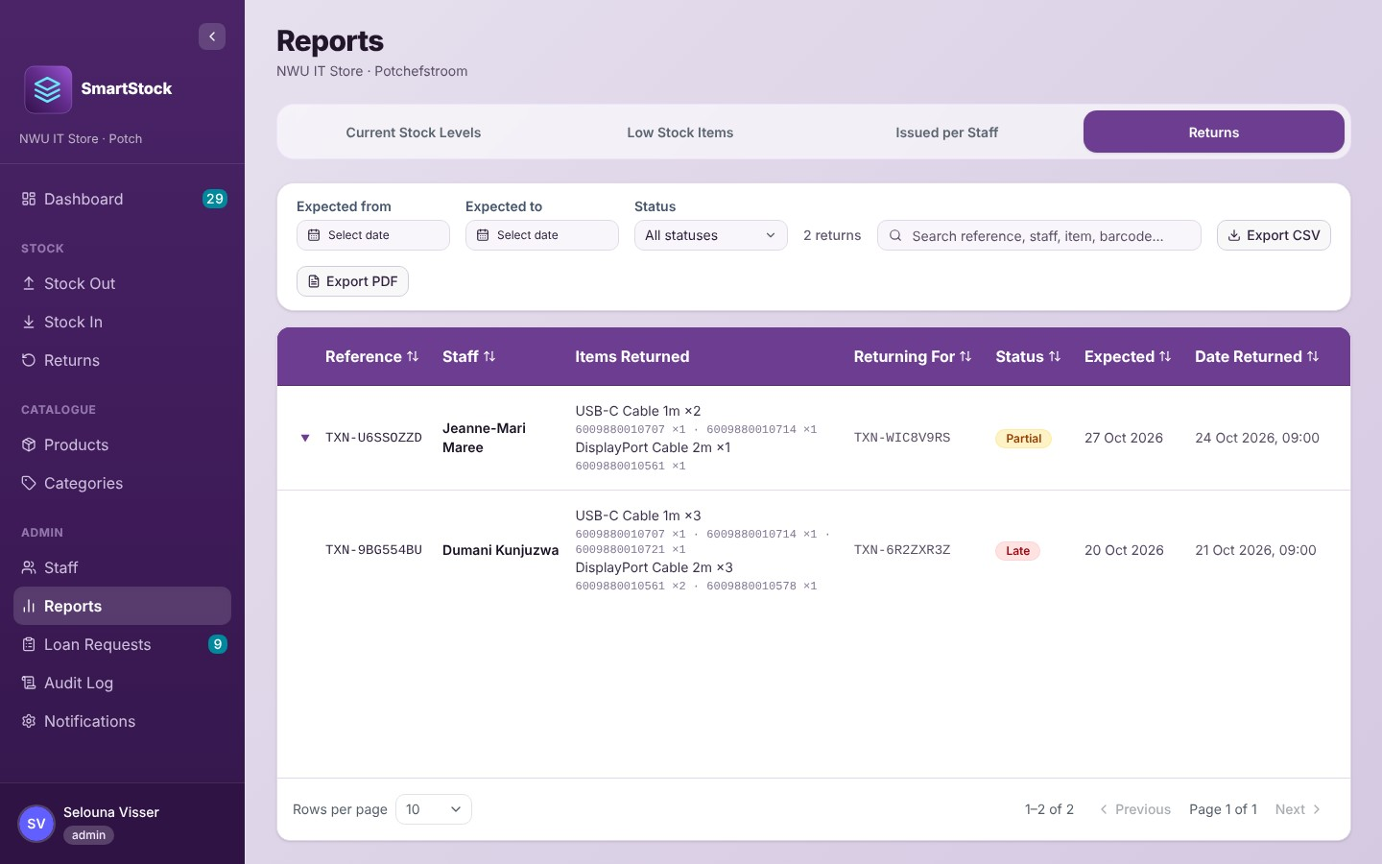
Figure 32: The Returns report

12. Audit Log
The Audit Log is the permanent history of the system: who changed what, and when. Every change to products, categories, staff records, Stock In/Out/Returns, write-offs, loan requests and notification settings writes an entry at the same moment. (Changes to your own My Profile details are not logged.) Entries cannot be edited or deleted from the app. It also serves as the full transaction history.
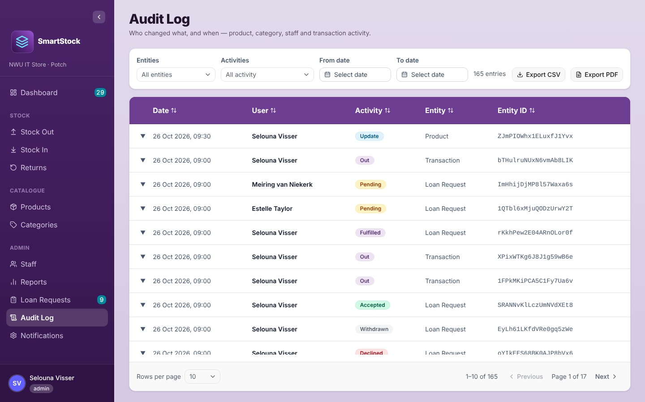
Figure 33: The Audit Log

12.1 Filtering
- Entities: the kind of record (Product, Category, Staff, Transaction, Loan Request, Settings).
- Activities: what happened, grouped as Stock movements (In, Out, Return, Adjust, Resolved), Loan requests (Pending, Countered, Accepted, Fulfilled, Declined, Expired, Withdrawn, Not picked up), Record changes (Create, Update, Delete, Activate, Deactivate) and Portal access (Portal Access Granted, Login Link Resent).
- From date / To date: both days are included.
- Clear filters resets everything. Export CSV and Export PDF export all matching entries with their details.

12.2 Reading an entry
Click a row to open it. A Stock Out, for example, shows the reference, the staff member, the operator, the loan request it fulfilled, each product with its barcodes, the lend window and, if the staff member was chosen from the list rather than by card, a Manual entry — no card scan badge (Returns show it too). Product changes show each field as old → new, including the reason for a quantity change. Click Show raw data for the full technical record.
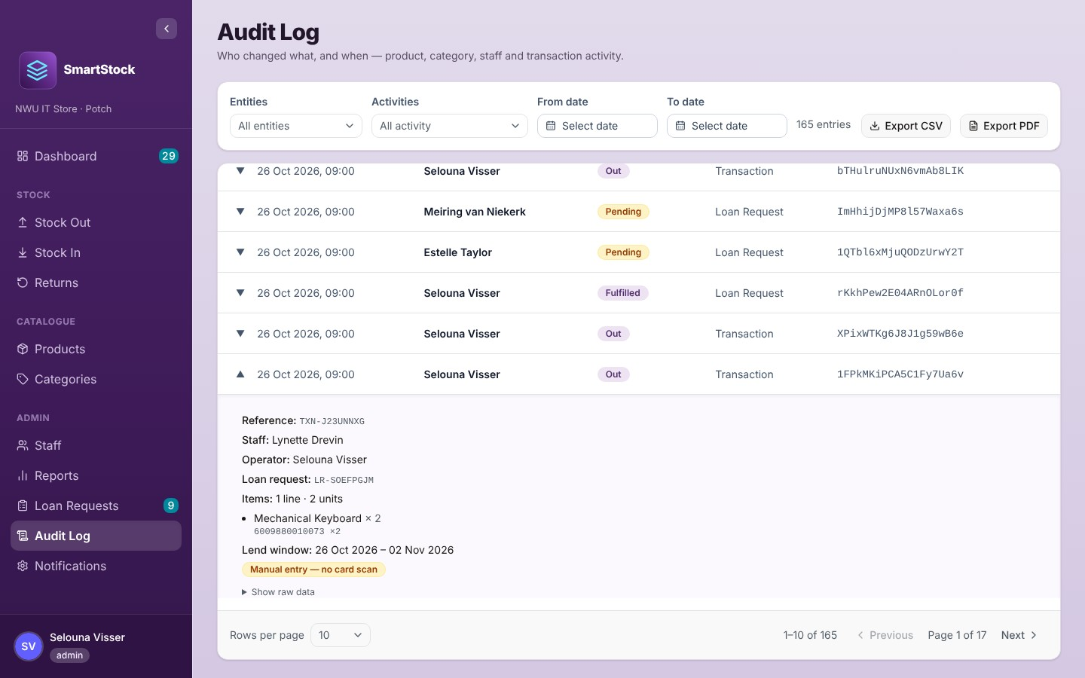
Figure 34: An expanded Stock Out entry with the manual-entry flag
Note: Changes the system makes by itself (closing an expired request, marking a missed pickup) are shown with the user "System (automatic)".

13. Notification Settings
SmartStock sends emails when important things happen. On this page you choose where administrator emails go, which address emails come from, and switch individual emails on or off.
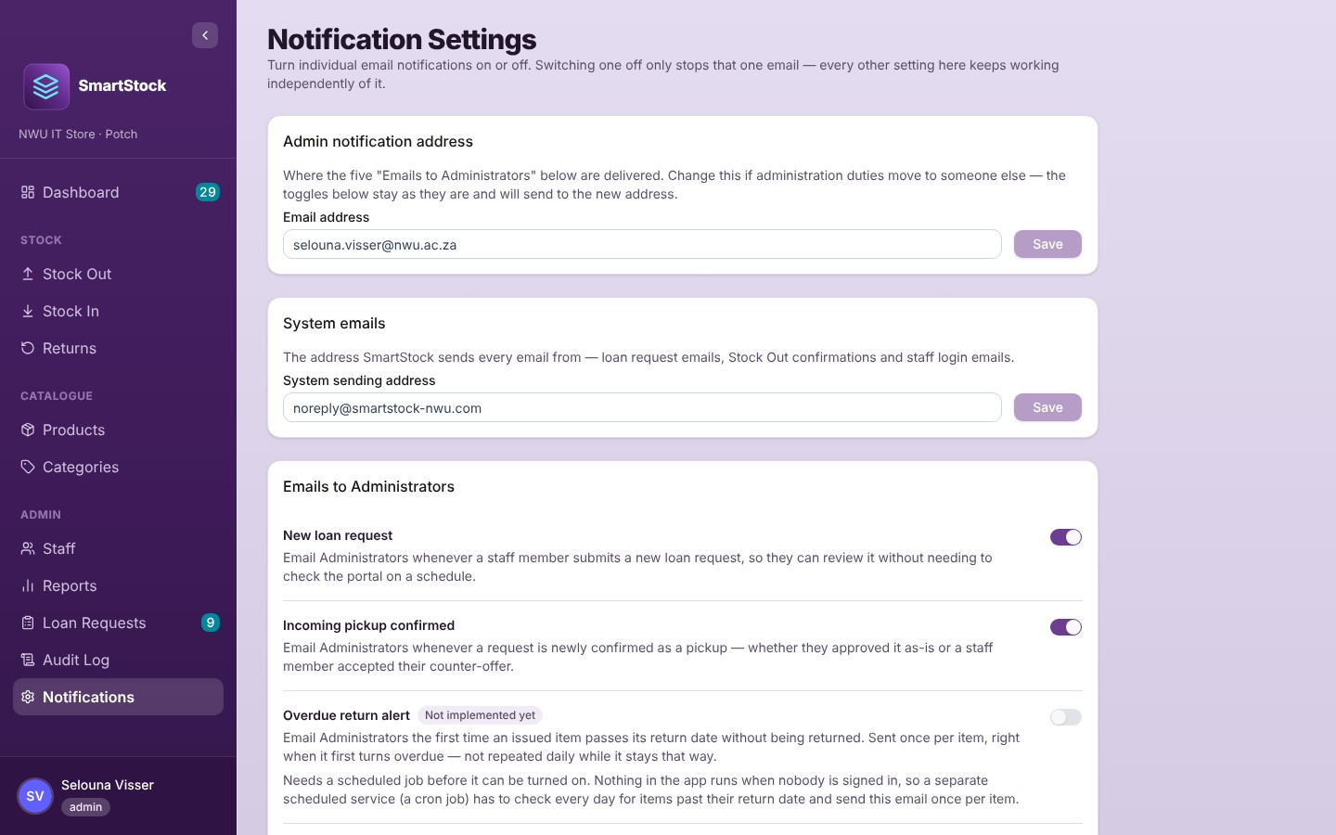
Figure 35: Notification Settings

13.1 Addresses
- Admin notification address: where the five "Emails to Administrators" are delivered. Change it if someone else takes over the store. This address is also shown as the contact email on the portal and the sign-in page. Click Save after changing it. Until an address is saved, the page says "Not set yet" and administrator emails are not sent.
- System sending address: the "from" address on every SmartStock email. Clear it and save to go back to the default.

13.2 The email switches
Each switch saves immediately. Switching one off only stops that one email. Every change is recorded in the Audit Log.
Emails to Administrators | Sent when
New loan request | A staff member submits a request.
Incoming pickup confirmed | A request becomes approved (you approved it, or the staff member accepted your counter).
Low stock / out of stock alert | A Stock Out or a product edit makes a product newly low (from above its reorder threshold to at or below it). It is not repeated while the product stays low.
Overdue return alert | Not implemented yet (always off).
Incoming pickup insufficient stock | Not implemented yet (always off).

Emails to staff members |  | Sent when
Stock Out confirmation |  | Items are issued to them on Stock Out.
Loan request approved |  | You approve their request as-is.
Loan request countered |  | You send them a counter-offer.
Loan request declined |  | You decline their request (including one you have already countered).
Approved pickup cancelled |  | You cancel their pickup on the Dashboard.
Counter offer accepted |  | They accept your counter (a confirmation for them).
Counter offer declined |  | They decline your counter (a confirmation for them).
Loan request withdrawn |  | They withdraw a request.
Loan request expired |  | Not implemented yet (always off).
Note: The three emails marked "Not implemented yet" need a scheduled job that runs every day even when nobody is using the system. This is planned future work, so these switches cannot be turned on (trying shows "… isn't implemented yet, so it can't be turned on.").
Notification emails are only sent when the server's email service is configured. If it is not, they are not sent, whatever the switches say.
Password and login emails (Send/Resend Login Email, Forgot password) are always sent and are not controlled by these switches. They use the System sending address when the server's email service is configured; otherwise Firebase sends its standard version.
On the demonstration site all emails are delivered to a test mailbox (Mailtrap), not to real inboxes.

14. My Profile (administrator)
Open it from your name at the bottom of the sidebar → Profile.
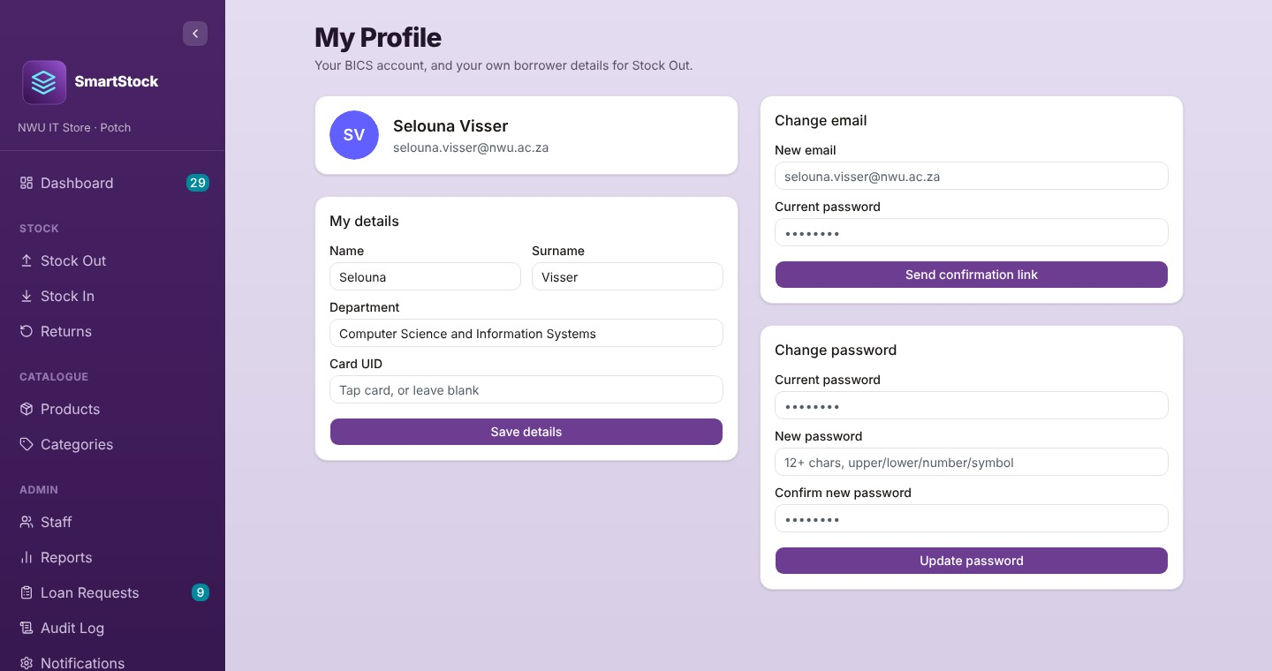
Figure 36: My Profile
Card | Use it to
My details | Set your name, surname, department and card UID, then Save details. This also creates your own borrower record, so you can select yourself on Stock Out when you take equipment.
Change email | Type the new email and your current password, then Send confirmation link. Your login email only changes when you click the link sent to the new address; then click I've clicked the link — check now. Depending on the Firebase settings, the old address may also receive a link to undo the change.
Change password | Type your current password and the new one twice (see the password rules in 2.3), then Update password.

Part B: Lending Portal guide (for staff)

15. About the Lending Portal
The Lending Portal lets NWU staff see what the IT Store can lend and ask to borrow it. Open the SmartStock address; the portal is the first page. You can browse without signing in, but you need an account to submit a request. To get an account, ask the IT Store; you will receive a "Set your SmartStock password" email (section 2.4).

How lending works
- Browse the equipment and add what you need to your cart.
- Choose your pickup dates and submit the request.
- The IT Store approves it, sends you a counter-offer (for example fewer units or other dates) or declines it. You are emailed each time (when the IT Store has those emails switched on).
- If you receive a counter-offer, accept or decline it on My Requests.
- Once approved, collect the equipment at the Potchefstroom BICS IT Service Desk during your pickup window. Bring your NWU staff card if you have one.
- Return the equipment by the agreed date.
Important: Adding items to your cart does not reserve them. Once you submit, the units are set aside for your request while it is reviewed, and they are confirmed once the IT Store approves it.

The portal screen
- The top bar has Browse, Cart (the badge shows how many units are in it) and My Requests (the badge shows your open requests).
- Signed in, a round badge with two letters taken from your email address appears on the right; click it for Profile and Sign out. Visitors see Sign In.
- The Lending Policy link is at the bottom of every page.
- On your first visit a small notice explains the essential cookies the portal uses; click Got it.
- On a phone, the menu button (three lines) opens Browse, My Requests and Profile; the magnifier opens the search and filters; the cart icon opens your cart.
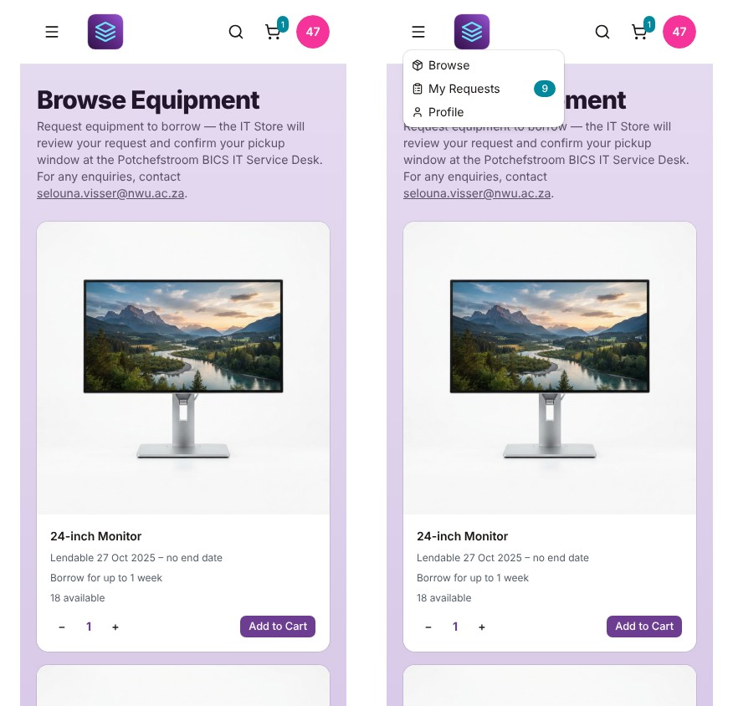
Figure 37: The portal on a phone, with the menu open

16. Browsing equipment
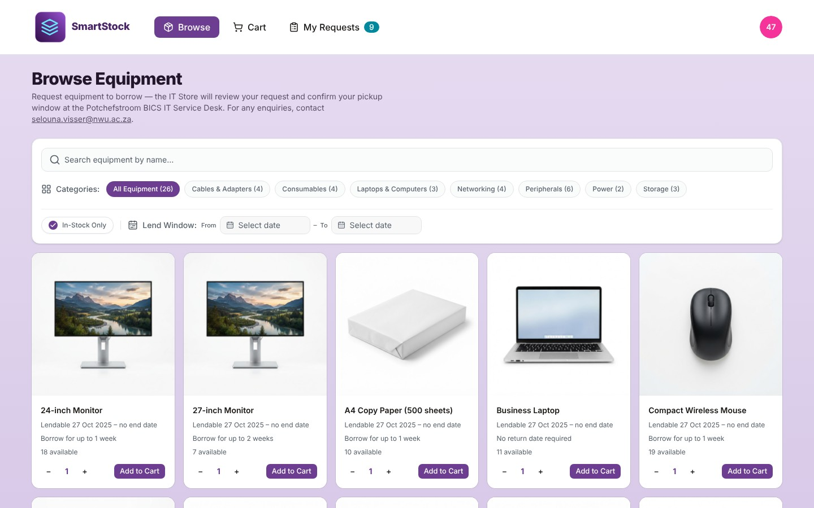
Figure 38: Browse Equipment (signed in)
- Search by product name.
- Categories: click a pill to show one category only.
- In-Stock Only (on by default) hides items that are out of stock or not offered. Untick it to see everything.
- Lend Window: choose From and To dates to see only items that can be borrowed for that whole period.
Each card shows the photo, the period in which the item can be borrowed, the longest loan allowed ("Borrow for up to 1 week", or "No return date required"), and how many are in stock (other people's requests for your dates are checked later, in the cart). Choose the quantity with − / + and click Add to Cart. Items that cannot be borrowed show Not Offered or Unavailable; when you are signed in, an out-of-stock item also shows when it is expected back (visitors see "return date not set").
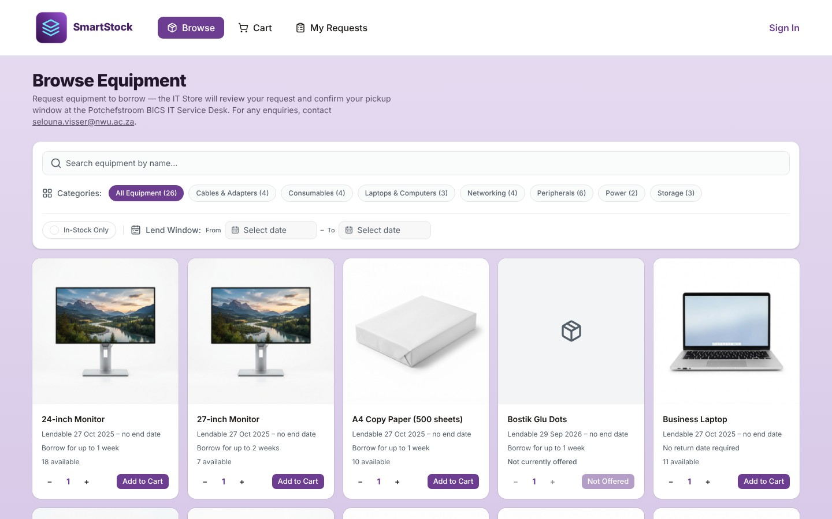
Figure 39: With In-Stock Only switched off, unavailable items are also shown
Click a card to see the product details: more photos, location, the period it can be borrowed in, the lending interval and the description. If the item can be borrowed, you can add it to your cart from there too.
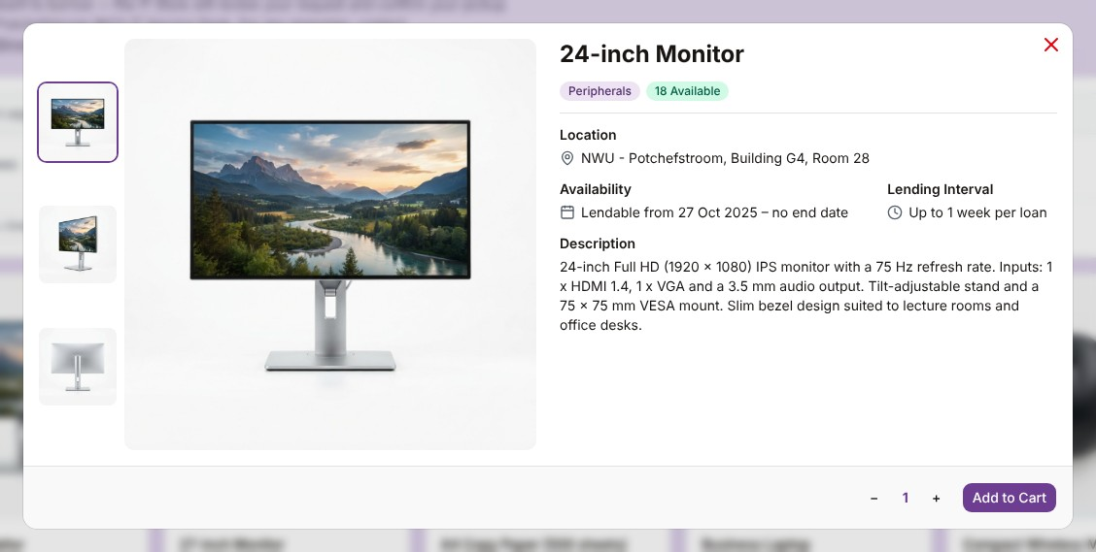
Figure 40: Product details

17. Your cart and submitting a request
- Click Cart. Check the items and quantities; click × to remove an item.
- Under Pickup dates, choose From (the day you want to collect). Then choose To (the day you will return it). The longest loan is set by the item with the shortest lending interval in your cart. To is optional only if every item can be borrowed indefinitely and none has a last lendable date.
- When you are signed in, the calendar shows green days (everything in your cart can be borrowed that day) and red days (an item is outside its lendable period, on the From calendar, or not enough stock remains once pending, countered and approved requests for those dates are counted). Greyed days cannot be chosen.
- Optionally write a Message to the administrator.
- Click Submit Request. You are taken to My Requests, and the administrator is notified.
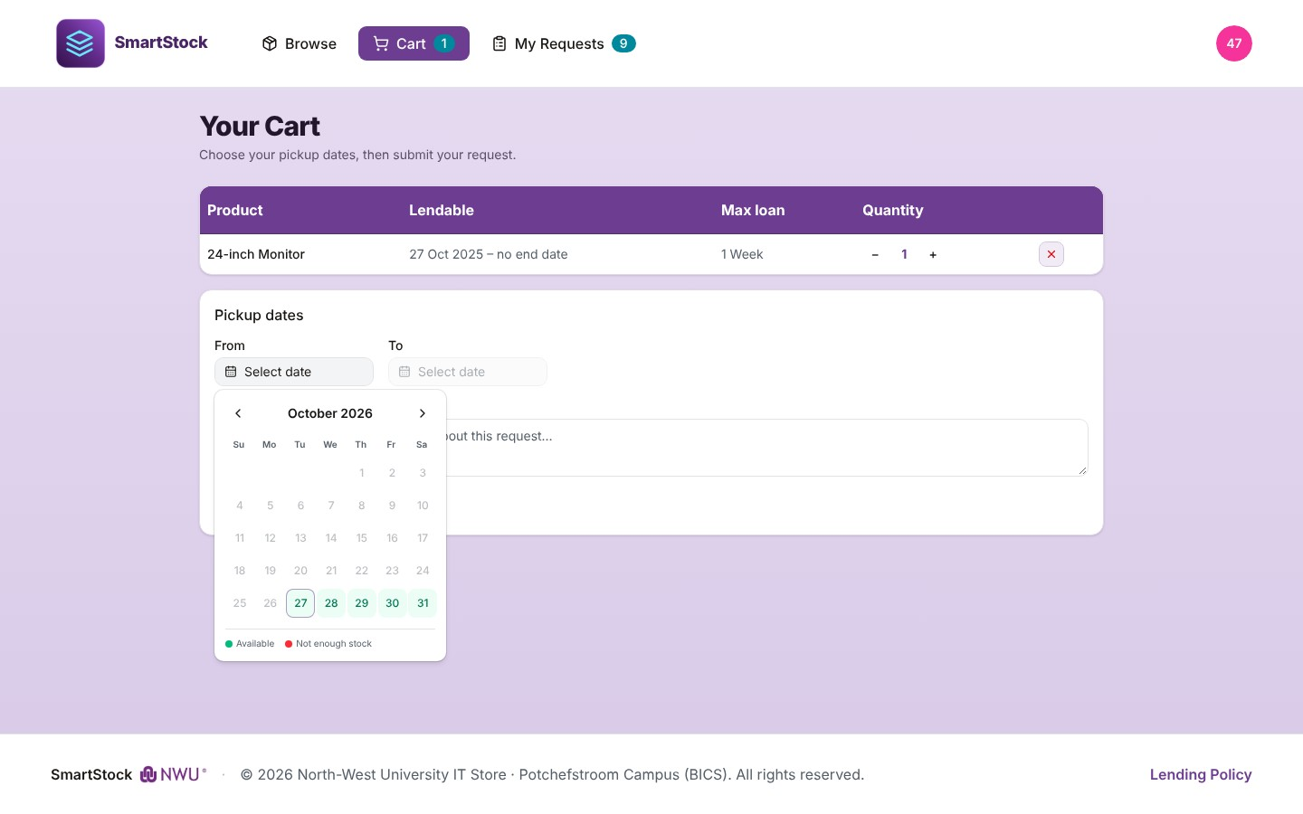
Figure 41: Choosing pickup dates: green days can be chosen without problems
If there is a problem, a red box lists it, for example "Select a To date — one or more items in your cart have a limited lending interval.", "only 1 unit(s) available for these dates" or "… is no longer offered — remove it from your cart." (the IT Store has stopped offering that item). Change the dates or quantities until the box disappears.
Note: If you are not signed in, Submit Request takes you to the sign-in page. After signing in you return to your cart with the same items; click Submit Request again.
The cart belongs to the browser tab. Closing the tab empties it.

18. My Requests
Follow every request you have made. Each request is a card with the dates, a reference such as LR-8KQ2M4ZD (quote it when you contact the IT Store) and a status. There are four tabs:
Tab | What is there | What you can do
Needs your response | Counter-offers from the administrator: what you asked for and what is offered, any date change, and the administrator's message. | Accept (it becomes an upcoming pickup) or Decline.
Awaiting review | Requests waiting for the IT Store. | Withdraw if you no longer need it.
Upcoming | Approved requests waiting for pickup. | Collect at the IT Service Desk, or Withdraw if your plans change. To change an approved request, withdraw it and submit a new one.
History | Finished requests: fulfilled, declined, withdrawn, expired and not picked up. | Nothing; for your records.
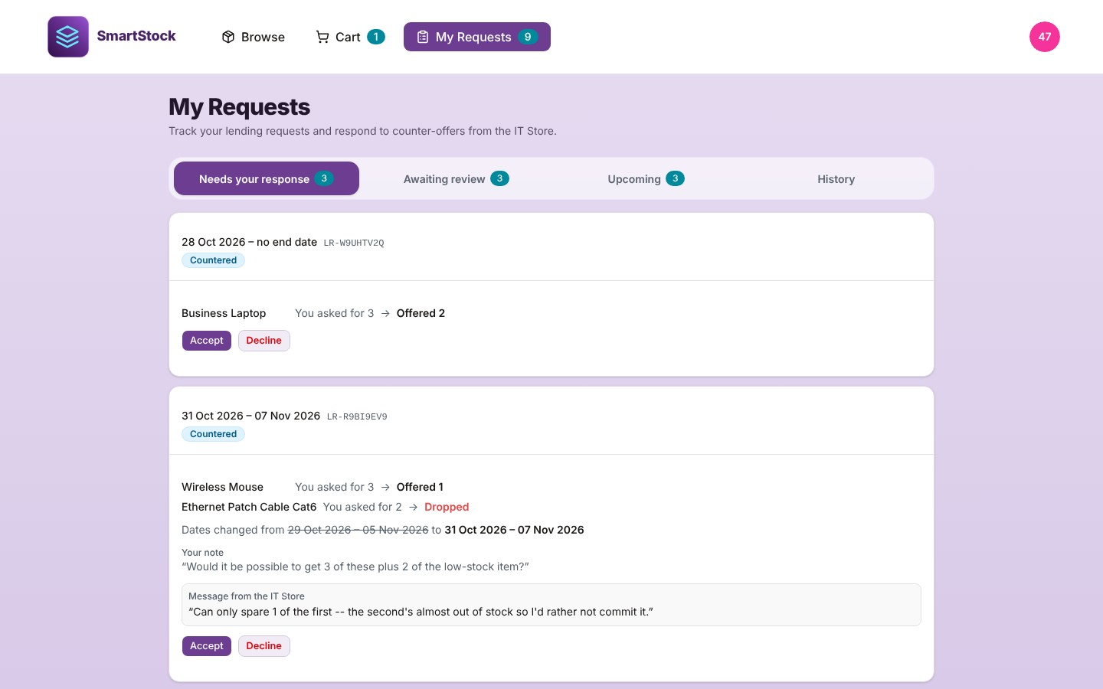
Figure 42: A counter-offer waiting for your answer
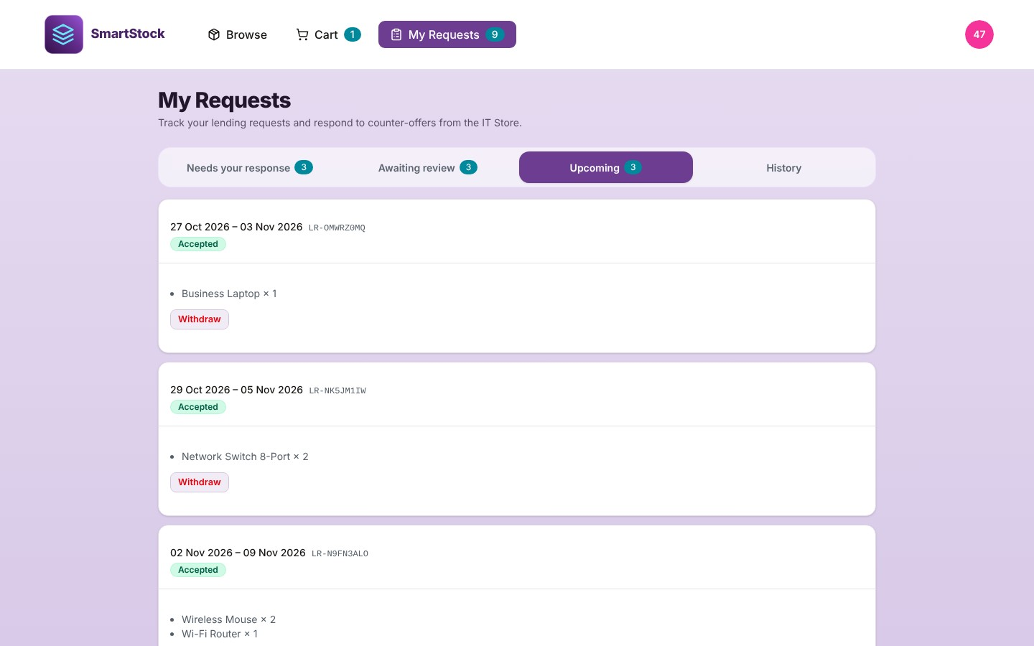
Figure 43: Approved requests waiting for pickup
Important: A request waiting for review, or a counter-offer waiting for your answer, closes automatically (Expired) 30 days after it last changed, or after your requested start date if that comes sooner.
An approved request that is not collected before its return (To) date has passed is marked Not picked up and the equipment is released. A request with no return date is not marked automatically.

19. Profile and Lending Policy

19.1 Your profile
Click the round badge at the top right → Profile. It shows your details as the IT Store has them (name, email, department, card UID and portal access). Contact the IT Store to have them changed.
To change your password, type your current password and the new one twice and click Update password. If you have forgotten your current password, click Forgot password?; a reset link is emailed to you.
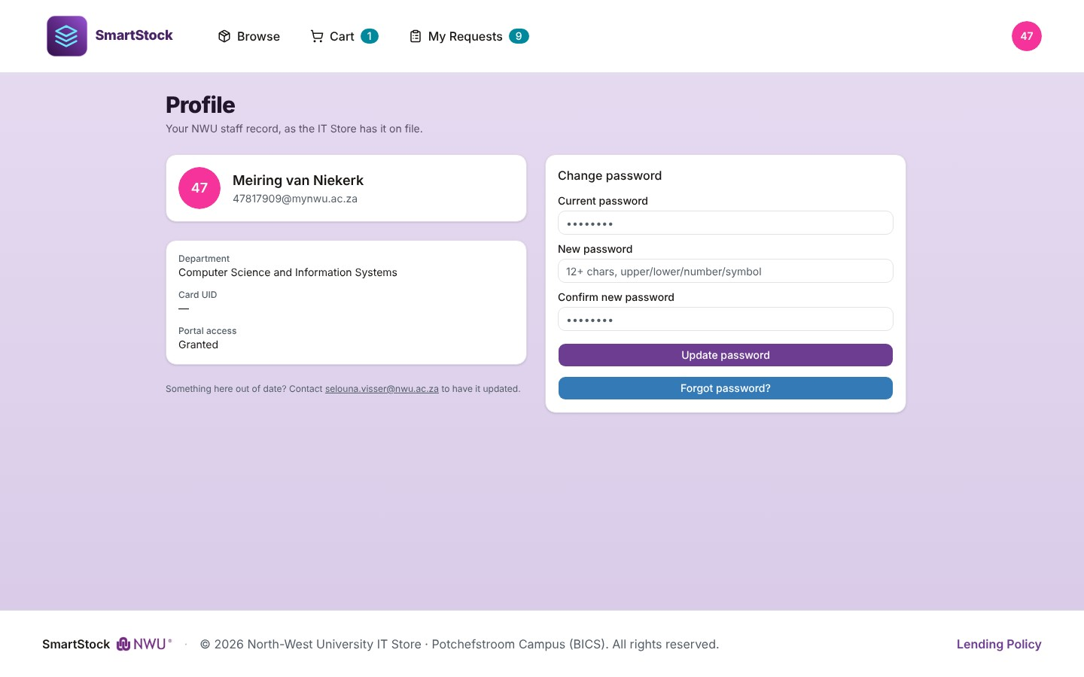
Figure 44: The staff Profile page

19.2 Lending Policy
The Lending Policy (link at the bottom of every page) explains who may borrow, how requests and reviews work, loan duration, cancelling, requests not picked up, caring for equipment, enquiries and privacy (POPIA and cookies).
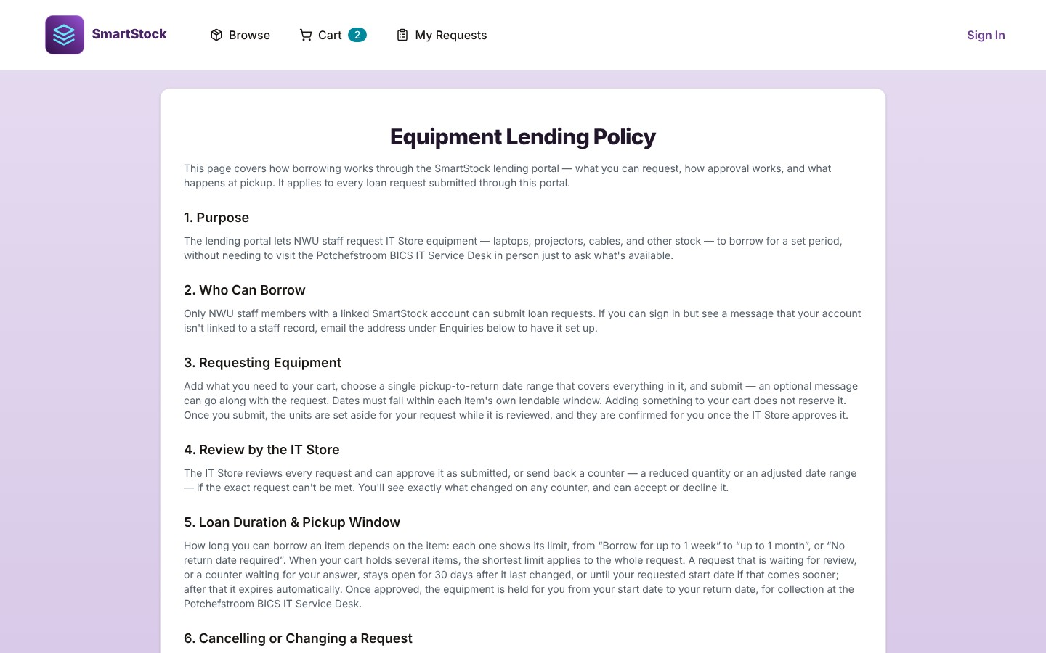
Figure 45: The Equipment Lending Policy

20. Everyday tasks (quick recipes)

A staff member collects an approved request
- Stock Out → tap their card (or Select staff manually).
- Click their request under Accepted Loan Requests.
- Scan every item until nothing shows "Awaiting scan".
- Review & Confirm →, check the dates, Confirm Issue.

Someone walks in without a request
- Stock Out → identify them → scan the items.
- Review & Confirm → set Lend From and Lend To → Confirm Issue.

Equipment comes back
- Returns → identify the person.
- Scan each item once per unit (use + for a lost label).
- Confirm Return.

A delivery arrives
- New product? Add it on Products first, with its barcode.
- Stock In → scan the items → add the supplier in Notes → Confirm Receipt.

A new staff member must be able to borrow
- Staff → Add Staff (link the card if they have it).
- Click Send Login Email so they can use the Lending Portal.

A staff member leaves the university
- Staff → expand their row to check what they still hold; take back or Resolve those items.
- Click Deactivate and confirm.

Monthly stock check
- Reports → Current Stock Levels → Export PDF (or CSV) and count the shelves.
- Correct differences on Products → Edit → Qty On Hand, with a reason.
- Reports → Low Stock Items → order more.

21. Questions and messages
Question or message | Answer
Card not registered. Use "Select manually"… | The card is not linked to an active staff member. Select the person manually, and add the Card UID to their record on the Staff page.
Barcode "…" not found. | The barcode is not registered to any product. Add it to the right product under Products → Edit.
… is out of stock / Only N of … in stock | You cannot issue more than is on hand. Check the quantity on Products.
Scan the exact barcode that was scanned at Stock Out. | On Returns, the item came back under a different barcode from the one it went out with. Scan the original label, or use the lost-label + button.
… can't be issued — it's fully reserved by … | Another staff member has a request for those units. Cancel that pickup on the Dashboard or decide the pending request first.
This request has already changed — reload to see its current state. | Someone else (or the system) acted on the request at the same time. Reload the page.
This product has stock history … and can't be deleted. | Products with history are kept. Set Availability to Unavailable instead.
Saved, but the email couldn't be sent. | The change is saved; only the email failed. Tell the person directly if it matters.
A staff member says they did not get the login email | Check the email address on their record, ask them to check their spam folder, and click Resend Login Email.
A staff member sees "Your account has been deactivated" | Activate them on the Staff page (if they should have access).
An item is lost for good | Resolve it from the Dashboard or the Staff page.
Why does a missed pickup still show as approved? | The system closes missed pickups the next time any admin page (or the staff member's portal) is opened after the pickup window has passed in South African time. If it still shows as approved, the last day of the window has not passed yet.

Appendix: limitations to be aware of
- The Overdue return alert, Incoming pickup insufficient stock and Loan request expired emails are not built yet (chapter 13). Overdue items and short pickups are shown on the Dashboard instead.
- Switching a product to Unavailable hides it from the Browse page while In-Stock Only is ticked (with it unticked the product shows as Not Offered). An Unavailable item that is still in someone's cart cannot be submitted; requests submitted before the switch stay on Loan Requests for you to decide.
- Label printing is done outside SmartStock: copy the generated barcode value into the label printer's software.
- Sign-ins are handled by the login service and are not listed in the Audit Log.

